** DEWAN INSTITUTE OF MANAGEMENT STUDIES**

**TIFFIN SERVICE SYSTEM**

**Major Project Report [BCA-605]**

**Bachelors Of Computer Applications**

**2020-2023**

Under the guidance of Assistant Professor **Mr. Neeraj Kr. Gupta**

**Submitted By:**

Tarun Chaudhary - 200986106105

Kushagra Gulati - 200986106058

Nutan Sharma - 200986106074

Tushar Rana - 200986106107

**ACKNOWLEDGEMENT**

The satisfaction that accompanies that the successful completion of any task would be incomplete without the mention of people whose ceaseless cooperation made it possible, whose constant guidance and encouragement crown all efforts with success.

We are grateful to our project guide **Mr. Neeraj Kr. Gupta** for the guidance, inspiration and constructive suggestions that helpful us in the preparation of this project.

We also thank our colleagues who have helped in successful completion of the project.

**Tarun Chaudhary**

**Kushagra Gulati**

**Nutan Sharma**

**Tushar Rana**

**DECLARATION**

We hereby declare that the project work entitled “**Tiffin Service System**” submitted to **DIMS, Meerut** is a record of an original work done by us under the guidance of **Mr. Neeraj Kr. Gupta** (Assistant Professor) of Dewan Institute of Management Studies, and this project work is submitted in the partial fulfillment of there requirements for the award of the degree of **Bachelor of Computer Applications**. The results embodied in this is have not been submitted to any other University or Institute for the award of any degree or diploma.

**Index**

**Chapter 1: Introduction 5-6**

1.1 Introduction

1.2 Objective

**Chapter 2: Tools and Environment 7**

* 1. Software Requirement
  2. Hardware Requirement

**Chapter 3: Analysis Document 8-11**

3.1 Identification of Need

3.2 Requirement Analysis

3.3 Feasibility Study

**Chapter 4: Design Document 12-23**

4.1 ER Diagram

4.2 Class Diagram

4.3 DFD

4.4 Data Dictionary

4.5 Modularization

**Chapter 5: Implementation 24-174**

5.1 Source Code

**Chapter 6: Testing 175-177**

6.1 Testing

**Chapter 7: Input Output Screens 176-186**

**Chapter 8: Limitations 187**

**Chapter 9: Future Scope 188**

**Chapter 10: Bibliography 189**

**INTRODUCTION AND OBJECTIVE**

**Introduction**

The Tiffin Delivery System Project aims to simplify the process of ordering and delivering meals for customers in a convenient and efficient way. The system is designed to cater the needs of individuals who are too busy to prepare their meals or those who prefer homemade food over restaurant meals.

The project will involve the development of a platform that will enable customers to browse through various menus, select their preferred meals, and place orders. The system will also feature a payment gateway that will facilitate secure transactions.

Once an order is placed, a delivery executive will be assigned to pick up the food from the vendor and deliver it to the customer's location. The system will provide real-time updates on the status of the delivery, allowing customers to track their orders.

The Tiffin Delivery System Project aims to provide a seamless and hassle-free experience to customers while also empowering small businesses that specialize in homemade food. With this platform, customers can enjoy delicious and healthy meals without the inconvenience of cooking or traveling to a restaurant.

**Objectives:**

1. To provide a convenient and affordable meal delivery service to customers.
2. To ensure timely delivery of fresh and hygienic meals to customers.
3. To offer a variety of meal options to cater to different dietary preferences and requirements.
4. To maintain a seamless and user-friendly ordering and payment system.
5. To implement effective tracking and management of orders and delivery logistics.
6. To establish a reliable and trustworthy brand image in the market.

**Requirement Specifications**

**Software Requirements:**

* Front-End - JDK 8 or above.
* Back-End – MySQL.
* Operating System – Windows XP or above.
* IDE – IntelliJ IDEA

**Hardware Requirements:**

* Desktop PC or a Laptop
* Intel® CoreTM i3-6006U CPU @ 2.00GHz
* RAM - 4.00 GB (recommended for smooth performance)
* 64-bit operating system, x64 based processor
* 1024 x 786 monitor resolution
* Keyboard and Mouse

**User Requirements:**

There should be a software platform that allows working `individuals to order homemade and delicious food online hassle-free, promoting their good health and well-being.

**System Requirements:**

There should be a database backup of the Tiffin Service System. There should be a Java supported framework for the system. Operating system should be Windows XP or any higher version of windows

**Analysis Document**

**Identification of Need**

The identification of needs for a tiffin service system involves understanding the requirements and desires of potential users and stakeholders.

1. **User Authentication and Access Control:** The project requires a robust login and authentication mechanism to differentiate between customers, administrators, and employees. This is crucial to ensure that the right individuals can access their respective dashboards and functionalities securely.
2. **User Registration and Management:** To facilitate engagement, the system needs an efficient sign-up process. This includes collecting and managing user information such as names, contact details, and security questions. The system should be capable of distinguishing between customer and employee registrations.
3. **Password Recovery and Security:** A password recovery mechanism is essential to assist users who forget their passwords. It should utilize security questions to verify users' identities and enable them to reset their passwords securely.
4. **Customer Dashboard:** The project should offer a dedicated dashboard for customers. This dashboard could include features like placing orders, viewing order history, selecting meal preferences, and updating personal information.
5. **Reporting and Analytics:** The admin dashboard should provide insightful reports and analytics, helping administrators make informed decisions about the business's performance and growth strategies.

**Requirement Analysis**

A requirement analysis for a tiffin service system involves identifying and defining the functionalities, features, and constraints of the system.

1. **User Roles:**

- Identification of different types of users (customers, administrators, delivery personnel, etc.).

- Description of the responsibilities and privileges of each user role.

**2. Functional Requirements:**

- User Registration and Authentication:

- Customers should be able to register and create accounts.

- Users should be able to log in using valid credentials.

- Menu Management:

- Chefs/admins can create, update, and delete tiffin items.

- Tiffin items should have details like name, description, price, and availability.

- Order Placement:

- Customers can browse the menu and place orders for tiffin items.

- Customers can select delivery dates and times.

- Users can specify dietary preferences or restrictions.

- Order Management:

- Admins should be able to view and manage customer orders.

- Admins can mark orders as prepared, dispatched, or delivered.

-Delivery Tracking:

- Customers can track the status of their orders.

- Delivery personnel can update order status after each step.

- Payment:

- Customers should be able to make payments online securely.

- Integration with various payment gateways.

- User Profiles:

- Users can view and update their profiles.

- Admins can manage user profiles.

- Notifications:

- Users receive notifications for order confirmation, updates, and delivery.

- Feedback and Ratings:

- Customers can provide feedback and ratings for tiffin items and service.

1. **Non-Functional Requirements:**

- Usability:

- The system should have an intuitive and user-friendly interface.

- Responsiveness across different devices and screen sizes.

- Performance:

- The system should handle a large number of concurrent users.

- Fast loading times for menu items and order tracking.

- Security:

- User data and payment information should be securely stored.

- Encryption for sensitive data.

- Scalability:

- The system should be designed to accommodate future growth in terms of users and orders.

- Reliability:

- Minimize system downtime.

- Backup and recovery mechanisms for data.

**Feasibility Study**

A feasibility study is a critical step in assessing the viability of a project or system before committing resources to its development.

1. **Technical Feasibility:**

- Is the required technology available and feasible to implement the tiffin service system?

- Are there any technical limitations that might hinder the system's development or operation?

- Can the system be integrated with existing technology infrastructure?

1. **Operational Feasibility:**

- Will the tiffin service system improve the existing operational processes, or will it create challenges?

- Can the staff easily adapt to the new system?

- Are the required resources available to operate the system effectively?

1. **Schedule Feasibility:**

- Can the tiffin service system be developed and deployed within the desired timeframe?

- Are there any potential delays or obstacles that might affect the project timeline?

1. **Risk Assessment:**

- What are the potential risks and challenges associated with developing and operating the tiffin service system?

- How can these risks be mitigated or managed?

1. **Scalability:**

- Can the tiffin service system scale to accommodate increased demand in the future?

- What are the plans for expansion and growth?

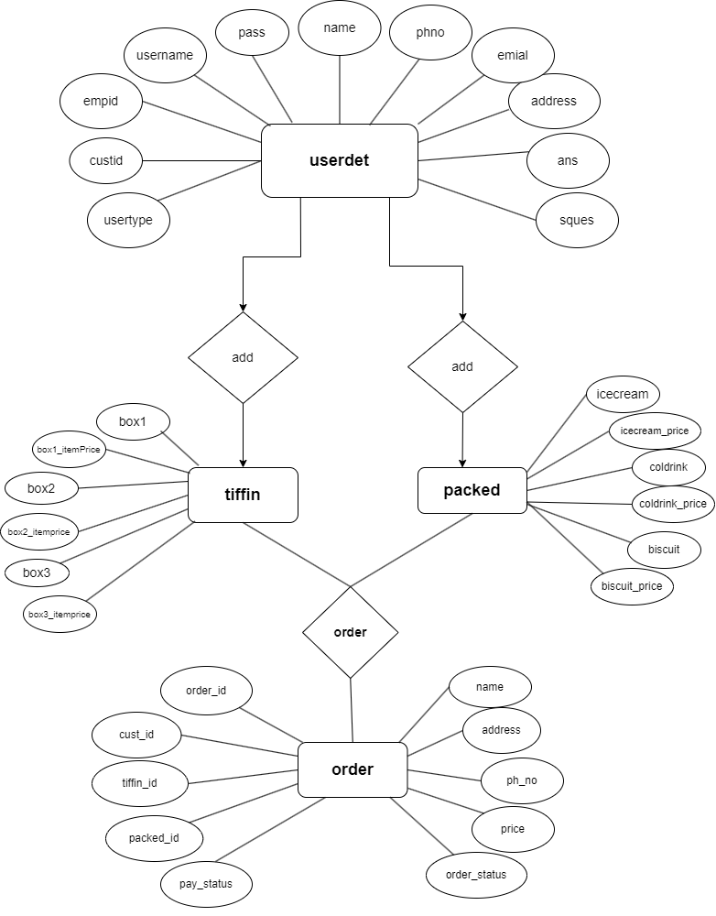**ER Diagram**

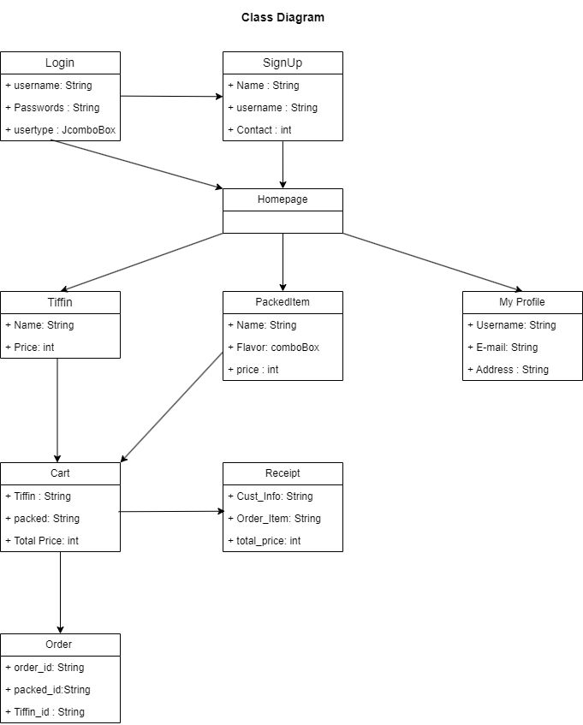**Class Diagram**

**Data Flow Diagram (DFD)**

**CFD**

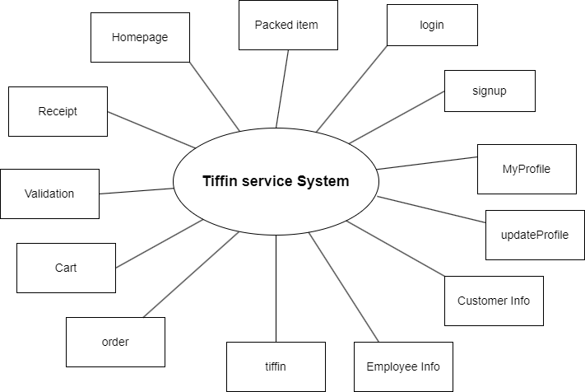

**0 Level DFD**

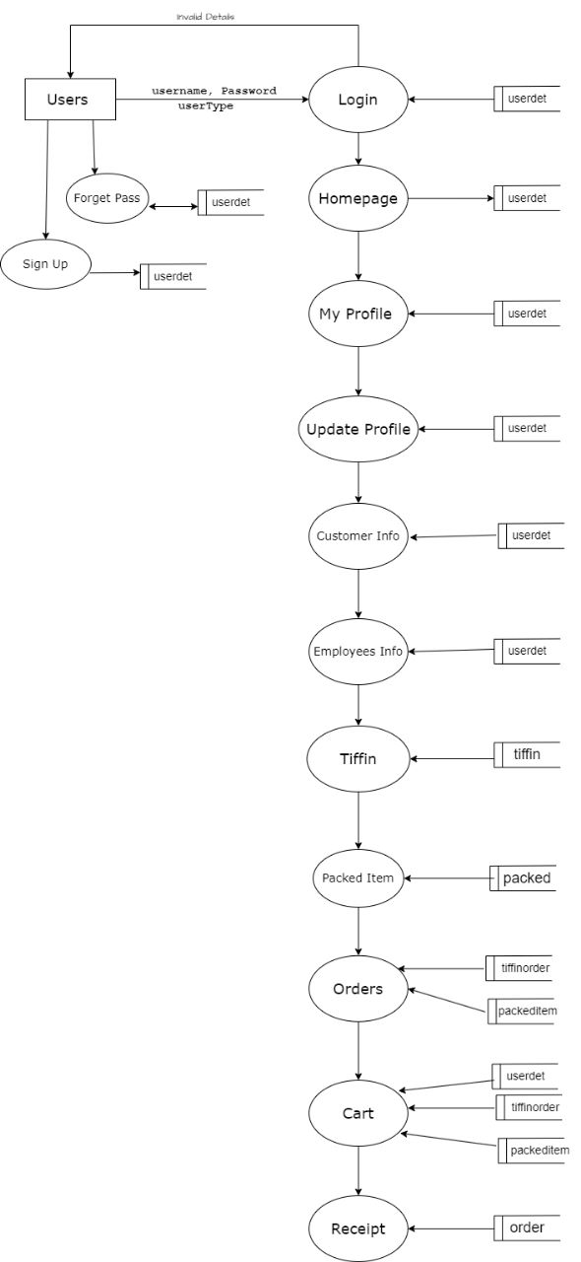

**1 Level DFD**

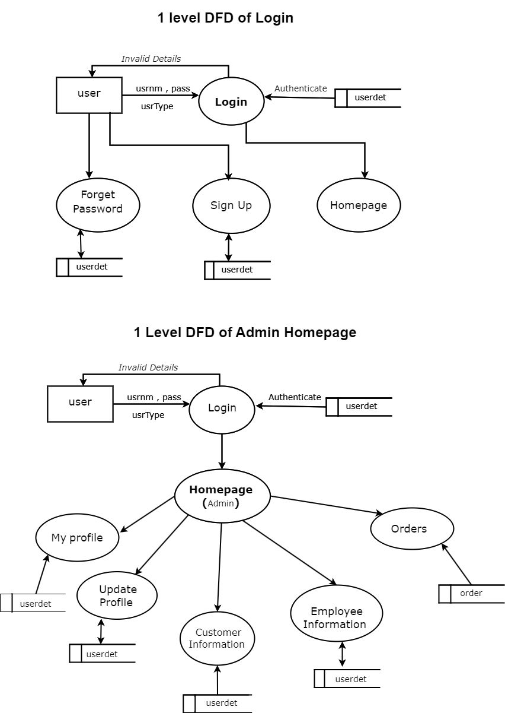

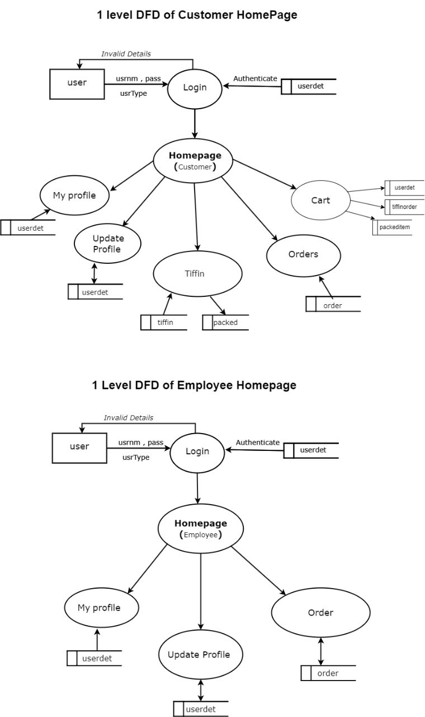

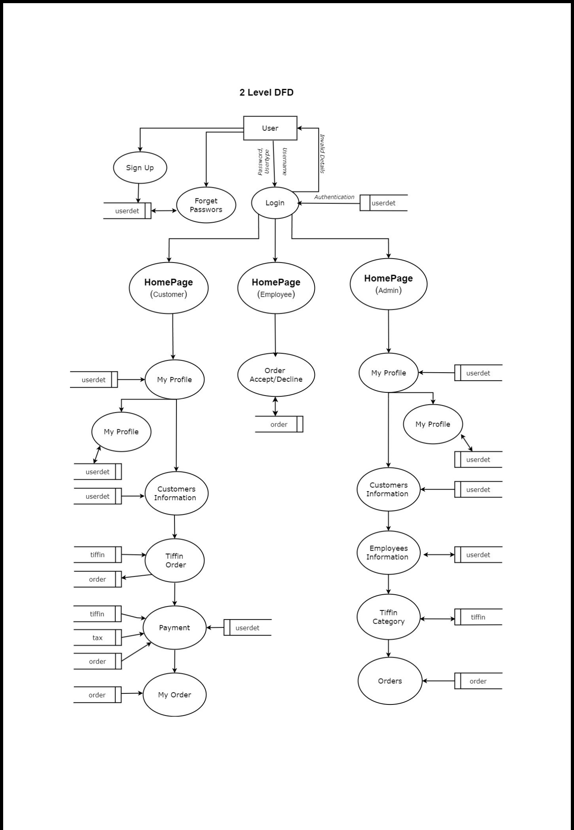**2 Level DFD**

**Data Dictionary**

1. **order**

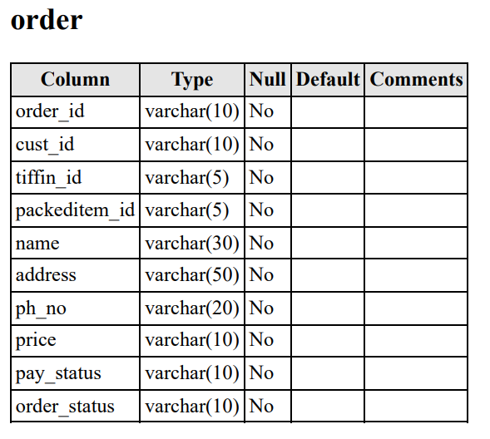

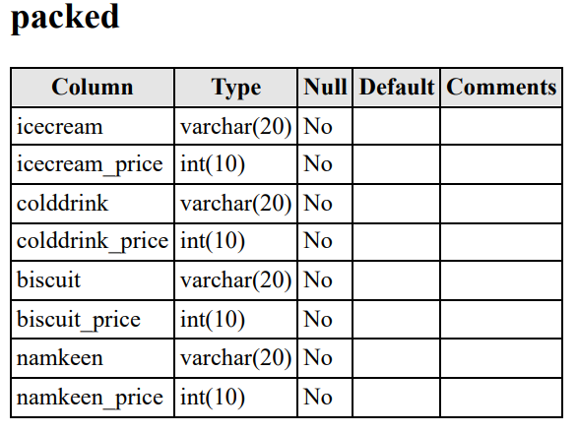**2. packed**

**3. packedorder**

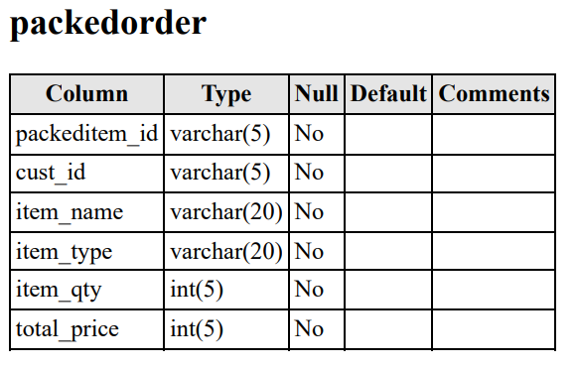

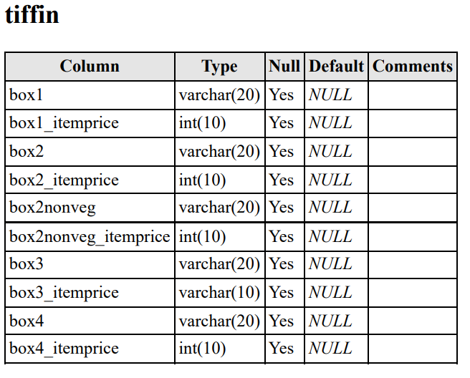**4. tiffin**

**5. tiffinorder  
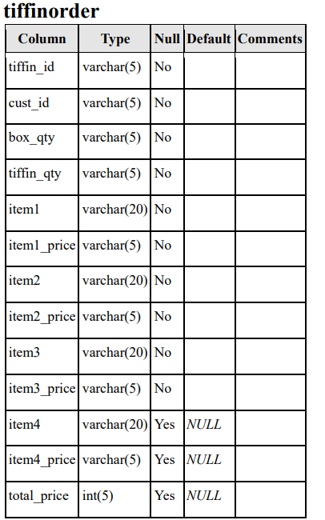  
  
  
  
  
  
  
  
  
  
  
  
  
  
  
  
  
  
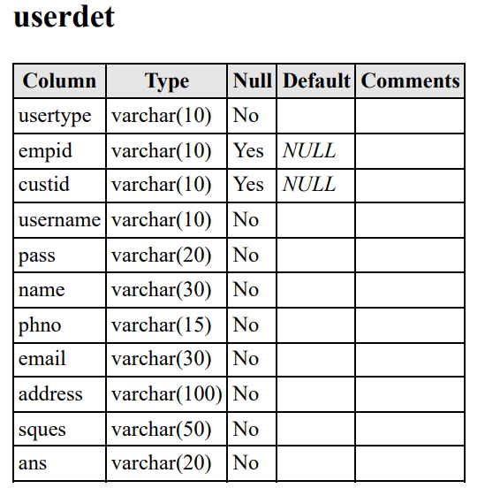6. userdet**

**Design Docs**

**Modularization**

1. **Login Module:** This module handles user authentication and access control. It includes components for user login, validation of credentials, and redirection to specific dashboards based on user roles.
2. **Sign Up Module:** The sign-up module is responsible for user registration. It includes components for collecting user information, validating data, creating user accounts, and sending confirmation emails.
3. **Forgot Module:** This module is enables user to reset their forgotten password. It typically involves a secure process where user answers a security question, and create a new password. This enhances access and security.
4. **My Profile Module:** This module provides users with access to their profiles. It includes components for displaying user information, order history, and account details.
5. **Customer Information Module:** This module manages customer data. It includes components for adding, updating, and deleting customer information. Admins can use this module to maintain accurate customer records.
6. **Employee Information Module:** Similar to the customer module, this module handles employee data. It includes components for managing employee details, roles, and responsibilities.
7. **Tiffin Module:** The tiffin module focuses on tiffin options. It includes components for displaying available tiffin choices, their descriptions, and prices.
8. **Orders Module:** This module manages customer orders. It includes components for placing orders, order tracking, and order history.
9. **Cart Module:** The cart module handles the shopping cart functionality. It includes components for adding and removing items, calculating totals, and managing quantities.
10. **Receipt Module:** The receipt module generates receipts for completed orders. It includes components for displaying order summaries, payment details, and delivery information.
11. **Validation Module:** The validation module ensures data integrity. It includes components for validating input data, such as passwords, email addresses, and form submissions.
12. **Homepage Module:** The homepage module is the entry point for users. It includes components for presenting an overview of the system's features and providing navigation options.
13. **Packed Item Module:** This module manages packed items for tiffin.  
     It includes components for assembling items, tracking inventory,  
     and ensuring accurate packing.

**Source Code**

**Database**

package TiffinSerSys;

import java.sql.*;

public class Database {

Connection c;

Statement s;

Database(){

try{

Class.forName("com.mysql.jdbc.Driver");

c = DriverManager.getConnection("jdbc:mysql://localhost:3306/tss?characterEncoding=latin1","root","");

s = c.createStatement();

System.out.println("Connected Successfully");

} catch (Exception e){

e.printStackTrace();

}

}

public static void main(String[] args) {

new Database();

}

}

**Validation**

package TiffinSerSys;

public class Validation {

public boolean nameValidate(String name){

boolean flag = true;

if(name.length() == 0) {

flag = false;

} else {

for(int i=0; i<name.length(); i++){

if( !((name.charAt(i) >= 65 && name.charAt(i) <= 90) || (name.charAt(i) >= 97 && name.charAt(i) <= 122) || (name.charAt(i) == ' ') || (name.charAt(i) == '.') ) ) {

flag = false;

break;

}

}

}

return flag;

}

public boolean usrnameValidate(String usrName){

boolean flag = true;

if(usrName.length() == 0 ) {

flag = false;

} else {

for(int i=0; i<usrName.length(); i++){

if(!( (usrName.charAt(i) >=65 && usrName.charAt(i) <=90) || (usrName.charAt(i) >=97 && usrName.charAt(i) <=122) || (usrName.charAt(i) >= 48 && usrName.charAt(i) <= 57) || (usrName.charAt(i) == '_') ) ) {

flag = false;

}

}

}

return flag;

}

public boolean passValidate(String pass) {

boolean flag = true;

int u_Count = 0, l_Count = 0, num_Count = 0, s_Count = 0;

if(pass.length() > 8 ){

for(int i=0; i<pass.length(); i++) {

if(pass.charAt(i)>=65 && pass.charAt(i)<90) {

u_Count++;

}

else if(pass.charAt(i)>=97 && pass.charAt(i)<122) {

l_Count++;

}

else if(pass.charAt(i)>=46 && pass.charAt(i)<57) {

num_Count++;

}

else if((pass.charAt(i)>=33 && pass.charAt(i)<64) || pass.charAt(i) == '@' ) {

s_Count++;

}

}

} else {

flag = false;

}

if( u_Count == 0 || l_Count == 0 || num_Count == 0 || s_Count == 0 ) {

flag = false;

}

return flag;

}

public boolean confirmPassValidate(String cpass, String pass) {

boolean flag = false;

if(cpass.equals(pass)) {

flag = true;

}

return flag;

}

public boolean contactValidate(String contact){

boolean flag = true;

int len = contact.length();

if(len != 10){

flag =false;

} else {

for (int i = 0; i < len; i++) {

if ((contact.charAt(i) < 46 && contact.charAt(i) > 57)) {

flag = false;

break;

}

}

}

return flag;

}

public boolean emailValidate(String email) {

boolean flag = true;

if(email.length()>6){

for(int i=0; i<email.length(); i++){

// if the char is not belong to Alphabet or number then set flag to FALSE else its good to go

if( !( (email.charAt(i) >=65 && email.charAt(i) <=90) || (email.charAt(i) >= 97 && email.charAt(i) <=122 ) || (email.charAt(i) >= 48 && email.charAt(i) <=57 ) )) {

flag = false;

}

}

} else {

flag = false;

}

return flag;

}

public boolean houseValidate (String houseNo){

boolean flag = true;

// only alphanumeric and space are allowed

if(houseNo.length() != 0){

for(int i=0; i<houseNo.length(); i++) {

if(!( (houseNo.charAt(i) >= 65 && houseNo.charAt(i) <=90 ) || (houseNo.charAt(i) >=97 && houseNo.charAt(i) <=122) || (houseNo.charAt(i) >= 47 && houseNo.charAt(i) <=57 ) || (houseNo.charAt(i) == 32) || (houseNo.charAt(i) == ',') ) ) {

flag = false;

break;

}

}

} else {

flag = false;

}

return flag;

}

public boolean colonyValidate (String colony){

boolean flag = true;

// Only Alphabet and Space is allowed

if(colony.length() != 0){

for(int i=0; i<colony.length(); i++) {

if(!( (colony.charAt(i) >= 65 && colony.charAt(i) <=90 ) || (colony.charAt(i) >=97 && colony.charAt(i) <=122) || (colony.charAt(i) == 32) ) ) {

flag = false;

break;

}

}

} else {

flag = false;

}

return flag;

}

public boolean cityValidate (String city){

boolean flag = true;

// Only Alphabet and Space is allowed

if(city.length() != 0){

for(int i=0; i<city.length(); i++) {

if(!( (city.charAt(i) >= 65 && city.charAt(i) <=90 ) || (city.charAt(i) >=97 && city.charAt(i) <=122) || (city.charAt(i) == 32) ) ) {

flag = false;

break;

}

}

} else {

flag = false;

}

return flag;

}

public boolean stateValidate (String state){

boolean flag = true;

// Only Alphabet and Space, dot(.) is allowed

if(state.length() != 0){

for(int i=0; i<state.length(); i++) {

if(!( (state.charAt(i) >= 65 && state.charAt(i) <=90) || (state.charAt(i) >=97 && state.charAt(i) <=122) || (state.charAt(i) == 32) || state.charAt(i) == '.') ) {

flag = false;

break;

}

}

} else {

flag = false;

}

return flag;

}

public boolean picodeValidate (String pincode){

boolean flag = true;

// Only number is allowed

if(pincode.length() != 0){

for(int i=0; i<pincode.length(); i++) {

if(!( pincode.charAt(i)>=48 && pincode.charAt(i)<=57 ) ) {

flag = false;

break;

}

}

} else {

flag = false;

}

return flag;

}

public boolean addressValidate (String addStr) {

boolean flag = true;

if(addStr.length()!=0) {

for(int i=0; i<addStr.length(); i++) {

if (!( (addStr.charAt(i) >= 65 || addStr.charAt(i)<=90 ) || ( addStr.charAt(i) >= 97 || addStr.charAt(i)<=122) || (addStr.charAt(i)>=48 && addStr.charAt(i)<=57) )) {

flag = false;

}

}

} else {

flag = false;

}

return flag;

}

public static void main(String[] args) {

new Validation();

}

}

**Signup**

package TiffinSerSys;

import javax.swing.*;

import java.awt.*;

import java.awt.event.*;

import java.sql.ResultSet;

public class signup extends JFrame implements ActionListener , KeyListener{

JLabel nameLabel, userTypeLabel, empIdLabel, customerIdLabel, userNameLabel, passwordLabel, confirmPasswordLabel, squesLabel, ansLabel, phoneLabel, emailLabel, addressLabel, houseStreetNoLabel, colonyLabel, cityLabel, stateLabel, pincodeLabel;

JTextField nameText, idText, userNameText, passText, confirmPassText, ansField, phoneText, emailText, houseStreetNoText, colonyText, cityText, stateText, pincodeText;

JComboBox<String> userTypeChoise,squesComboBox, domainComboBox;

JButton submitButton,backButton;

Database db = new Database();

// Warning Labels

JLabel nameWar, usernmWar, passWar, confirmpassWar, phoneWar, emailWar, houseWar, colonyWar, cityWar, stateWar, pincodeWar;

public signup() {

setSize(700, 740);

setLayout(null);

setLocationRelativeTo(null);

setDefaultCloseOperation(JFrame.DISPOSE_ON_CLOSE); // Once completed change it into the DISPOSE_ON_CLOSE

JLabel heading = new JLabel("Sign Up Form");

heading.setFont(new Font("Cascadia Code SemiBold", Font.BOLD, 25));

heading.setBounds(220, 20, 200, 30);

add(heading);

// --- Labels ---

nameLabel = new JLabel("Name ");

nameLabel.setBounds(50, 80, 100, 25);

nameLabel.setFont(new Font("Damask", Font.BOLD, 14));

add(nameLabel);

userTypeLabel = new JLabel("User Type ");

userTypeLabel.setBounds(50, 120, 100, 25);

userTypeLabel.setFont(new Font("Damask", Font.BOLD, 14));

add(userTypeLabel);

empIdLabel = new JLabel("Employee ID ");

empIdLabel.setBounds(50, 160, 100, 25);

empIdLabel.setFont(new Font("Damask", Font.BOLD, 14));

add(empIdLabel);

customerIdLabel = new JLabel("Customer ID");

customerIdLabel.setBounds(50, 160, 100, 25);

customerIdLabel.setFont(new Font("Damask", Font.BOLD, 14));

add(customerIdLabel);

customerIdLabel.setVisible(false);

userNameLabel = new JLabel("UserName ");

userNameLabel.setBounds(50, 200, 100, 25);

userNameLabel.setFont(new Font("Damask", Font.BOLD, 14));

add(userNameLabel);

passwordLabel = new JLabel("Password ");

passwordLabel.setBounds(50, 240, 100, 25);

passwordLabel.setFont(new Font("Damask", Font.BOLD, 14));

add(passwordLabel);

confirmPasswordLabel = new JLabel("Confirm Password ");

confirmPasswordLabel.setBounds(50, 280, 150, 25);

confirmPasswordLabel.setFont(new Font("Damask", Font.BOLD, 14));

add(confirmPasswordLabel);

squesLabel = new JLabel("Security Question ");

squesLabel.setBounds(50, 320, 150, 25);

squesLabel.setFont(new Font("Damask", Font.BOLD, 14));

add(squesLabel);

ansLabel = new JLabel("Answer ");

ansLabel.setBounds(50, 360, 150, 25);

ansLabel.setFont(new Font("Damask", Font.BOLD, 14));

add(ansLabel);

phoneLabel = new JLabel("Phone Number ");

phoneLabel.setBounds(50, 400, 150, 25);

phoneLabel.setFont(new Font("Damask", Font.BOLD, 14));

add(phoneLabel);

emailLabel = new JLabel("E-Mail ");

emailLabel.setBounds(50, 440, 150, 25);

emailLabel.setFont(new Font("Damask", Font.BOLD, 14));

add(emailLabel);

addressLabel = new JLabel("Address ");

addressLabel.setBounds(50, 480, 150, 25);

addressLabel.setFont(new Font("Damask", Font.BOLD, 14));

add(addressLabel);

houseStreetNoLabel = new JLabel("House & Street No :");

houseStreetNoLabel.setBounds(180, 480, 120, 20);

houseStreetNoLabel.setFont(new Font("Arial", Font.PLAIN, 12));

add(houseStreetNoLabel);

colonyLabel = new JLabel("Colony/Area :");

colonyLabel.setBounds(180, 500, 150, 25);

colonyLabel.setFont(new Font("Arial", Font.PLAIN, 12));

add(colonyLabel);

cityLabel = new JLabel("City :");

cityLabel.setBounds(180, 520, 150, 25);

cityLabel.setFont(new Font("Arial", Font.PLAIN, 12));

add(cityLabel);

stateLabel = new JLabel("State :");

stateLabel.setBounds(180, 540, 150, 25);

stateLabel.setFont(new Font("Arial", Font.PLAIN, 12));

add(stateLabel);

pincodeLabel = new JLabel("Pincode :");

pincodeLabel.setBounds(180, 560, 150, 25);

pincodeLabel.setFont(new Font("Arial", Font.PLAIN, 12));

add(pincodeLabel);

// --- TextFields And 3 ComboBox ---

nameText = new JTextField();

nameText.setBounds(180, 85,150, 25);

add(nameText);

nameText.addKeyListener(this);

userTypeChoise = new JComboBox<>();

userTypeChoise.setBounds(180, 120, 150, 25);

userTypeChoise.addItem("--");

userTypeChoise.addItem("Admin");

userTypeChoise.addItem("Employee");

userTypeChoise.addItem("Customer");

add(userTypeChoise);

userTypeChoise.addItemListener(new ItemListener() {

@Override

public void itemStateChanged(ItemEvent ie) {

String userString = (String) userTypeChoise.getSelectedItem();

if (userString.equals("Customer")) {

empIdLabel.setVisible(false);

customerIdLabel.setVisible(true);

// Here I have to fetch the Customer last ID and then Increment the Id by 1 and Display it in the IDText Feild.

String custid = "";

try {

ResultSet rs = db.s.executeQuery("select custid from userdet where usertype = 'Customer' ORDER BY custid ASC");

while( rs.next() ){

custid = "";

custid = rs.getString("custid");

}

} catch (Exception e) {

e.printStackTrace();

}

if(custid.length()>0) {

int last_digit = custid.charAt(custid.length()-1) -'0';

last_digit++;

custid = custid.substring(0,custid.length()-1);

custid = custid + last_digit;

idText.setText(custid);

} else {

idText.setText("C001");

}

}

if (userString.equals("Admin")) {

empIdLabel.setVisible(true);

customerIdLabel.setVisible(false);

// Here I have to fetch the Admin last ID and then Increment the Id by 1 and Display it in the IDText Feild.

String admid = "";

try {

ResultSet rs = db.s.executeQuery("select empid from userdet where usertype = 'Admin' ORDER BY empid ASC");

while( rs.next() ){

admid = "";

admid = rs.getString("empid");

}

} catch (Exception e) {

e.printStackTrace();

}

if(admid.length()>0) {

int last_digit = admid.charAt(admid.length()-1) -'0';

last_digit++;

admid = admid.substring(0,admid.length()-1);

admid = admid + last_digit;

idText.setText(admid);

} else {

idText.setText("AE001");

}

}

if (userString.equals("Employee")) {

empIdLabel.setVisible(true);

customerIdLabel.setVisible(false);

// Here I have to fetch the Employee last ID and then Increment the Id by 1 and Display it in the IDText Feild.

String empid = "";

try {

ResultSet rs = db.s.executeQuery("select empid from userdet where usertype = 'Employee' ORDER BY empid ASC");

while( rs.next() ){

empid = "";

empid = rs.getString("empid");

}

} catch (Exception e) {

e.printStackTrace();

}

if(empid.length()>0) {

int last_digit = empid.charAt(empid.length()-1) -'0';

last_digit++;

empid = empid.substring(0,empid.length()-1);

empid = empid + last_digit;

idText.setText(empid);

} else {

idText.setText("E001");

}

}

}

});

idText = new JTextField();

idText.setBounds(180, 165, 150, 25);

add(idText);

idText.setEditable(false);

idText.addKeyListener(this);

userNameText = new JTextField();

userNameText.setBounds(180, 205, 150, 25);

add(userNameText);

userNameText.addKeyListener(this);

passText = new JTextField();

passText.setBounds(180, 245, 150, 25);

add(passText);

passText.addKeyListener(this);

confirmPassText = new JTextField();

confirmPassText.setBounds(180, 285, 150, 25);

add(confirmPassText);

confirmPassText.addKeyListener(this);

squesComboBox = new JComboBox<>();

squesComboBox.setBounds(180, 320, 200, 25);

squesComboBox.addItem("What is your Date Of Birth?");

squesComboBox.addItem("What is the name of your pet?");

squesComboBox.addItem("By which name your Friends Call you?");

squesComboBox.addItem("Your Favourite Color?");

add(squesComboBox);

ansField = new JTextField();

ansField.setBounds(180, 365, 150, 25);

add(ansField);

ansField.addKeyListener(this);

phoneText = new JTextField();

phoneText.setBounds(180, 405, 150, 25);

add(phoneText);

phoneText.addKeyListener(this);

emailText = new JTextField();

emailText.setBounds(180, 445, 150, 25);

add(emailText);

emailText.addKeyListener(this);

domainComboBox = new JComboBox<>();

domainComboBox.setBounds(340, 445, 100, 25);

domainComboBox.addItem("@gmail.com");

domainComboBox.addItem("@yahoo.com");

domainComboBox.addItem("@hackermail.com");

domainComboBox.addItem("@cyberdude.com");

add(domainComboBox);

houseStreetNoText = new JTextField();

houseStreetNoText.setBounds(300, 479, 150, 20);

add(houseStreetNoText);

houseStreetNoText.addKeyListener(this);

colonyText = new JTextField();

colonyText.setBounds(300, 501, 150, 20);

add(colonyText);

colonyText.addKeyListener(this);

cityText = new JTextField();

cityText.setBounds(300, 523, 150, 20);

add(cityText);

cityText.addKeyListener(this);

stateText = new JTextField();

stateText.setBounds(300, 545, 150, 20);

add(stateText);

stateText.addKeyListener(this);

pincodeText = new JTextField();

pincodeText.setBounds(300, 567, 150, 20);

add(pincodeText);

pincodeText.addKeyListener(this);

// -- 2 JButton --

submitButton = new JButton("Sign Up");

submitButton.setFont(new Font("Sans-serif ",Font.PLAIN,15));

submitButton.setBounds(80,600,200,30);

submitButton.setForeground(Color.white);

submitButton.setBackground(Color.BLACK);

add(submitButton);

submitButton.addActionListener(this);

submitButton.addKeyListener(this);

JLabel msgLabel = new JLabel("Already Have Account?");

msgLabel.setBounds(90,640,150,20);

msgLabel.setFont(new Font("Arial",Font.PLAIN,13));

add(msgLabel);

backButton = new JButton("Login");

backButton.setBorderPainted(false);

backButton.setContentAreaFilled(false);

backButton.setForeground(Color.blue);

backButton.setFont(new Font("Sans-serif ",Font.PLAIN,15));

backButton.setBounds(200,638,100,20);

add(backButton);

backButton.addActionListener(this);

// --- Warning Labels ---

nameWar = new JLabel("");

nameWar.setBounds(350, 85,150, 25);

nameWar.setForeground(Color.red);

nameWar.setFont(new Font("",Font.ITALIC,13));

add(nameWar);

usernmWar = new JLabel("");

usernmWar.setBounds(350, 205,150, 25);

usernmWar.setForeground(Color.red);

usernmWar.setFont(new Font("",Font.ITALIC,13));

add(usernmWar);

passWar = new JLabel("");

passWar.setBounds(350, 245, 150, 25);

passWar.setForeground(Color.red);

passWar.setFont(new Font("",Font.ITALIC,13));

add(passWar);

confirmpassWar = new JLabel("");

confirmpassWar.setBounds(350, 285, 150, 25);

confirmpassWar.setForeground(Color.red);

confirmpassWar.setFont(new Font("",Font.ITALIC,13));

add(confirmpassWar);

phoneWar = new JLabel("");

phoneWar.setBounds(350, 405,150, 25);

phoneWar.setForeground(Color.red);

phoneWar.setFont(new Font("",Font.ITALIC,13));

add(phoneWar);

emailWar = new JLabel("");

emailWar.setBounds(450, 445, 150, 25);

emailWar.setForeground(Color.red);

emailWar.setFont(new Font("",Font.ITALIC,13));

add(emailWar);

houseWar = new JLabel("");

houseWar.setBounds(450, 479, 150, 20);

houseWar.setForeground(Color.red);

houseWar.setFont(new Font("",Font.ITALIC,13));

add(houseWar);

colonyWar = new JLabel("");

colonyWar.setBounds(450, 501, 150, 20);

colonyWar.setForeground(Color.red);

colonyWar.setFont(new Font("",Font.ITALIC,13));

add(colonyWar);

cityWar = new JLabel("");

cityWar.setBounds(450, 523, 150, 20);

cityWar.setForeground(Color.red);

cityWar.setFont(new Font("",Font.ITALIC,13));

add(cityWar);

stateWar = new JLabel("");

stateWar.setBounds(450, 545, 150, 20);

stateWar.setForeground(Color.red);

stateWar.setFont(new Font("",Font.ITALIC,13));

add(stateWar);

pincodeWar = new JLabel("");

pincodeWar.setBounds(450, 567, 150, 20);

pincodeWar.setForeground(Color.red);

pincodeWar.setFont(new Font("",Font.ITALIC,13));

add(pincodeWar);

setVisible(true);

} // End Of Constructor....

public static void main(String[] args) {

new signup();

}

@Override

public void actionPerformed(ActionEvent ae) {

if(ae.getSource()==backButton){

new login();

setVisible(false);

} else if(ae.getSource()==submitButton) {

// Here We are Fetching the UserInput from the TextFields..

String name,usrtype,id,usrnm,pass,cpass,sque,ans,phno,email_username,email_domain,address,email;

name = nameText.getText();

usrtype = (String) userTypeChoise.getSelectedItem();

id = idText.getText();

usrnm = userNameText.getText();

pass = passText.getText();

cpass = confirmPassText.getText();

sque = (String) squesComboBox.getSelectedItem();

ans = ansField.getText();

phno = phoneText.getText(); // int ph = Integer.parseInt(phno);

email_username = emailText.getText();

email_domain = (String) domainComboBox.getSelectedItem();

email = email_username+email_domain;

address = houseStreetNoText.getText() +", "+ colonyText.getText() +", "+ cityText.getText()+", "+stateText.getText()+", "+pincodeText.getText();

boolean flag = true; // It means data is valid and data is ready to send to database.

boolean flag2 = true; // It means send it.

if(name.equals("") || id.equals("") || usrnm.equals("") || pass.equals("") || cpass.equals("") || ans.equals("") || phno.equals("") || email.equals("") || colonyText.getText().equals("") || cityText.getText().equals("") || stateText.getText().equals("") || pincodeText.getText().equals("")){

JOptionPane.showMessageDialog(null,"Please Enter Details ≡(▔﹏▔)≡");

flag2 = false;

} else {

Validation v = new Validation();

flag = v.nameValidate(name);

if(flag == false){

nameWar.setText("Invalid Format!!");

flag2 = false;

} else if(flag == true) {

nameWar.setText("");

}

flag = v.usrnameValidate(usrnm);

if(flag == false){

usernmWar.setText("Invalid Format!!");

flag2 = false;

} else if(flag == true) {

usernmWar.setText("");

}

flag = v.passValidate(pass);

if(flag == false){

passWar.setText("Invalid Format!!");

flag2 = false;

} else if(flag == true) {

passWar.setText("");

}

flag = v.confirmPassValidate(cpass, pass);

if(flag == false){

confirmpassWar.setText("Invalid Format!!");

flag2 = false;

} else if(flag == true) {

confirmpassWar.setText("");

}

flag = v.contactValidate(phno);

if(flag == false){

phoneWar.setText("Invalid Format!!");

flag2 = false;

} else if(flag == true) {

phoneWar.setText("");

}

flag = v.emailValidate(email_username);

if(flag == false){

emailWar.setText("Invalid Format!!");

flag2 = false;

} else if(flag == true) {

emailWar.setText("");

}

flag = v.houseValidate(houseStreetNoText.getText());

if(flag == false){

houseWar.setText("Invalid Format!!");

flag2 = false;

} else if(flag == true) {

houseWar.setText("");

}

flag = v.colonyValidate(colonyText.getText());

if(flag == false){

colonyWar.setText("Invalid Format!!");

flag2 = false;

} else if(flag == true) {

colonyWar.setText("");

}

flag = v.cityValidate(cityText.getText());

if(flag == false){

cityWar.setText("Invalid Format!!");

flag2 = false;

} else if(flag == true) {

cityWar.setText("");

}

flag = v.stateValidate(stateText.getText());

if(flag == false){

stateWar.setText("Invalid Format!!");

flag2 = false;

} else if(flag == true) {

stateWar.setText("");

}

flag = v.picodeValidate(pincodeText.getText());

if(flag == false){

pincodeWar.setText("Invalid Format!!");

flag2 = false;

} else if(flag == true) {

pincodeWar.setText("");

}

}

if(flag2 == true){

try{

if (usrtype.equals("Customer")){

db.s.executeUpdate(" INSERT INTO `userdet` (`usertype`, `empid`, `custid`, `username`, `pass`, `name`, `phno`, `email`, `address`, `sques`, `ans`) VALUES ('"+usrtype+"', NULL, '"+id+"', '"+usrnm+"', '"+pass+"', '"+name+"', '"+phno+"', '"+email+"', '"+address+"', '"+sque+"', '"+ans+"'); ");

JOptionPane.showMessageDialog(null,"Welcome To The Family of TSS😊");

nameText.setText("");

userTypeChoise.setSelectedIndex(0);

idText.setText("");

userNameText.setText("");

passText.setText("");

confirmPassText.setText("");

squesComboBox.setSelectedIndex(0);

ansField.setText("");

phoneText.setText("");

emailText.setText("");

houseStreetNoText.setText("");

colonyText.setText("");

cityText.setText("");

stateText.setText("");

pincodeText.setText("");

} else {

db.s.executeUpdate(" INSERT INTO `userdet` (`usertype`, `empid`, `custid`, `username`, `pass`, `name`, `phno`, `email`, `address`, `sques`, `ans`) VALUES ('"+usrtype+"', '"+id+"', NULL, '"+usrnm+"', '"+pass+"', '"+name+"', '"+phno+"', '"+email+"', '"+address+"', '"+sque+"', '"+ans+"'); ");

JOptionPane.showMessageDialog(null,"Welcome To The Family of TSS😊");

nameText.setText("");

userTypeChoise.setSelectedIndex(0);

idText.setText("");

userNameText.setText("");

passText.setText("");

confirmPassText.setText("");

squesComboBox.setSelectedIndex(0);

ansField.setText("");

phoneText.setText("");

emailText.setText("");

houseStreetNoText.setText("");

colonyText.setText("");

cityText.setText("");

stateText.setText("");

pincodeText.setText("");

}

} catch (Exception e){

e.printStackTrace();

}

}

}

} // End of Action Performed.

@Override

public void keyTyped(KeyEvent ke) {

}

@Override

public void keyPressed(KeyEvent ke) {

if(ke.getSource() == nameText || ke.getSource() ==userNameText || ke.getSource() == passText || ke.getSource() == confirmPassText || ke.getSource() == phoneText|| ke.getSource() == emailText || ke.getSource() == ansField || ke.getSource() == houseStreetNoText || ke.getSource() == colonyText || ke.getSource() == cityText || ke.getSource() == stateText ||ke.getSource() == pincodeText) {

if(ke.getKeyCode()==KeyEvent.VK_ENTER){

// when you press enter button code will execute

// Here We are Fetching the UserInput from the TextFields..

String name,usrtype,id,usrnm,pass,cpass,sque,ans,phno,email_username,email_domain,address,email;

name = nameText.getText();

usrtype = (String) userTypeChoise.getSelectedItem();

id = idText.getText();

usrnm = userNameText.getText();

pass = passText.getText();

cpass = confirmPassText.getText();

sque = (String) squesComboBox.getSelectedItem();

ans = ansField.getText();

phno = phoneText.getText(); // int ph = Integer.parseInt(phno);

email_username = emailText.getText();

email_domain = (String) domainComboBox.getSelectedItem();

email = email_username+email_domain;

address = houseStreetNoText.getText() +", "+ colonyText.getText() +", "+ cityText.getText()+", "+stateText.getText()+", "+pincodeText.getText();

boolean flag = true; // It means data is valid and data is ready to send to database.

boolean flag2 = true; // It means send it.

if(name.equals("") || id.equals("") || usrnm.equals("") || pass.equals("") || cpass.equals("") || ans.equals("") || phno.equals("") || email.equals("") || colonyText.getText().equals("") || cityText.getText().equals("") || stateText.getText().equals("") || pincodeText.getText().equals("")){

JOptionPane.showMessageDialog(null,"Please Enter Details ≡(▔﹏▔)≡");

flag2 = false;

} else {

Validation v = new Validation();

flag = v.nameValidate(name);

if(flag == false){

nameWar.setText("Invalid Format!!");

flag2 = false;

} else if(flag == true) {

nameWar.setText("");

}

flag = v.usrnameValidate(usrnm);

if(flag == false){

usernmWar.setText("Invalid Format!!");

flag2 = false;

} else if(flag == true) {

usernmWar.setText("");

}

flag = v.passValidate(pass);

if(flag == false){

passWar.setText("Invalid Format!!");

flag2 = false;

} else if(flag == true) {

passWar.setText("");

}

flag = v.confirmPassValidate(cpass, pass);

if(flag == false){

confirmpassWar.setText("Invalid Format!!");

flag2 = false;

} else if(flag == true) {

confirmpassWar.setText("");

}

flag = v.contactValidate(phno);

if(flag == false){

phoneWar.setText("Invalid Format!!");

flag2 = false;

} else if(flag == true) {

phoneWar.setText("");

}

flag = v.emailValidate(email_username);

if(flag == false){

emailWar.setText("Invalid Format!!");

flag2 = false;

} else if(flag == true) {

emailWar.setText("");

}

flag = v.houseValidate(houseStreetNoText.getText());

if(flag == false){

houseWar.setText("Invalid Format!!");

flag2 = false;

} else if(flag == true) {

houseWar.setText("");

}

flag = v.colonyValidate(colonyText.getText());

if(flag == false){

colonyWar.setText("Invalid Format!!");

flag2 = false;

} else if(flag == true) {

colonyWar.setText("");

}

flag = v.cityValidate(cityText.getText());

if(flag == false){

cityWar.setText("Invalid Format!!");

flag2 = false;

} else if(flag == true) {

cityWar.setText("");

}

flag = v.stateValidate(stateText.getText());

if(flag == false){

stateWar.setText("Invalid Format!!");

flag2 = false;

} else if(flag == true) {

stateWar.setText("");

}

flag = v.picodeValidate(pincodeText.getText());

if(flag == false){

pincodeWar.setText("Invalid Format!!");

flag2 = false;

} else if(flag == true) {

pincodeWar.setText("");

}

}

if(flag2 == true){

try{

if (usrtype.equals("Customer")){

db.s.executeUpdate(" INSERT INTO `userdet` (`usertype`, `empid`, `custid`, `username`, `pass`, `name`, `phno`, `email`, `address`, `sques`, `ans`) VALUES ('"+usrtype+"', NULL, '"+id+"', '"+usrnm+"', '"+pass+"', '"+name+"', '"+phno+"', '"+email+"', '"+address+"', '"+sque+"', '"+ans+"'); ");

JOptionPane.showMessageDialog(null,"Welcome To The Family of TSS😊");

nameText.setText("");

userTypeChoise.setSelectedIndex(0);

idText.setText("");

userNameText.setText("");

passText.setText("");

confirmPassText.setText("");

squesComboBox.setSelectedIndex(0);

ansField.setText("");

phoneText.setText("");

emailText.setText("");

houseStreetNoText.setText("");

colonyText.setText("");

cityText.setText("");

stateText.setText("");

pincodeText.setText("");

} else {

db.s.executeUpdate(" INSERT INTO `userdet` (`usertype`, `empid`, `custid`, `username`, `pass`, `name`, `phno`, `email`, `address`, `sques`, `ans`) VALUES ('"+usrtype+"', '"+id+"', NULL, '"+usrnm+"', '"+pass+"', '"+name+"', '"+phno+"', '"+email+"', '"+address+"', '"+sque+"', '"+ans+"'); ");

JOptionPane.showMessageDialog(null,"Welcome To The Family of TSS😊");

nameText.setText("");

userTypeChoise.setSelectedIndex(0);

idText.setText("");

userNameText.setText("");

passText.setText("");

confirmPassText.setText("");

squesComboBox.setSelectedIndex(0);

ansField.setText("");

phoneText.setText("");

emailText.setText("");

houseStreetNoText.setText("");

colonyText.setText("");

cityText.setText("");

stateText.setText("");

pincodeText.setText("");

}

} catch (Exception e){

e.printStackTrace();

}

}

}

}

}

@Override

public void keyReleased(KeyEvent ke) {}

} // Ends Of Class SignUp

**Login**

package TiffinSerSys;

import javax.swing.*;

import java.awt.*;

import java.awt.event.*;

import java.sql.ResultSet;

public class login extends JFrame implements ActionListener, KeyListener {

JFrame frame = new JFrame();

JPanel login_panel, forgetPass_panel;

// Login Jpanel components...

JTextField usernameTextField;

JPasswordField passTextField;

JComboBox<String> loginAsComboBox;

JButton loginButton, forgetButton, signupButton;

// PackedItem Component

JTextField usernameTextFieldf, answerTextField, newPasswordTextField, confirmPasswordTextField;

JComboBox<String> securityQuesComboBox;

JLabel newPasswordLabel, confirmPasswordLabel;

JLabel newPassWar,conPassWar; //used to show warning if password is not upto the requiremwnt OR not matching.

JButton updateButton, backButton;

Database db = new Database();

login() {

frame.setSize(800, 600);

frame.setDefaultCloseOperation(JFrame.EXIT_ON_CLOSE);

frame.setLayout(null);

frame.setLocationRelativeTo(null);

frame.setResizable(false);

frame.setTitle("Login");

// Login Panel

login_panel = new JPanel() {

public void paintComponent(Graphics g) {

ImageIcon img = new ImageIcon(ClassLoader.getSystemResource("icons/LoginBG.jpg"));

Image i = img.getImage();

g.drawImage(i, 0, 0, this.getWidth(), this.getHeight(), this);

}

};

login_panel.setLayout(null);

login_panel.setSize(frame.getWidth(), frame.getHeight());

JLabel usernameLabel = new JLabel("User Name ");

usernameLabel.setBounds(200, 150, 120, 20);

usernameLabel.setFont(new Font("Arial", Font.BOLD, 18));

usernameLabel.setForeground(Color.BLACK);

JLabel passwordLabel = new JLabel("Password ");

passwordLabel.setBounds(200, 200, 100, 20);

passwordLabel.setFont(new Font("Arial", Font.BOLD, 18));

passwordLabel.setForeground(Color.BLACK);

JLabel loginas = new JLabel("LoginAs ");

loginas.setBounds(200, 250, 100, 20);

loginas.setFont(new Font("Arial", Font.BOLD, 18));

loginas.setForeground(Color.BLACK);

usernameTextField = new JTextField();

usernameTextField.setBounds(340, 150, 180, 30);

usernameTextField.setFont(new Font("Consolas", Font.PLAIN, 16));

usernameTextField.setBorder(null);

usernameTextField.addKeyListener(this);

passTextField = new JPasswordField();

passTextField.setBounds(340, 200, 180, 30);

passTextField.setFont(new Font("Consolas", Font.PLAIN, 18));

passTextField.setEchoChar('*');

passTextField.setBorder(null);

passTextField.addKeyListener(this);

loginAsComboBox = new JComboBox<>();

loginAsComboBox.setBounds(340, 250, 180, 30);

loginAsComboBox.addItem("Admin");

loginAsComboBox.addItem("Customer");

loginAsComboBox.addItem("Employee");

loginAsComboBox.setBorder(null);

loginAsComboBox.addKeyListener(this);

signupButton = new JButton("Sign Up");

signupButton.setBounds(230, 320, 90, 30);

signupButton.setFont(new Font("Sans-serif ", Font.PLAIN, 15));

signupButton.addActionListener(this);

loginButton = new JButton("Login");

loginButton.setBounds(340, 320, 90, 30);

loginButton.setFont(new Font("Sans-serif ", Font.PLAIN, 15));

loginButton.addActionListener(this);

loginButton.addKeyListener(this);

forgetButton = new JButton("Forget Password");

forgetButton.setBounds(230, 370, 200, 30);

forgetButton.setFont(new Font("Sans-serif ", Font.PLAIN, 15));

forgetButton.addActionListener(this);

login_panel.add(usernameLabel);

login_panel.add(passwordLabel);

login_panel.add(loginas);

login_panel.add(usernameTextField);

login_panel.add(passTextField);

login_panel.add(loginAsComboBox);

login_panel.add(signupButton);

login_panel.add(loginButton);

login_panel.add(forgetButton);

//-------------------- Forget Password Panel -----------------------

forgetPass_panel = new JPanel();

forgetPass_panel.setLayout(null);

forgetPass_panel.setSize(600, 500);

JLabel heading2 = new JLabel("Forget Password");

heading2.setFont(new Font("Arial", Font.BOLD, 25));

heading2.setHorizontalAlignment(JLabel.LEFT);

heading2.setBounds(280, 20, 220, 30);

JLabel usernameLabelf = new JLabel("Username");

usernameLabelf.setBounds(50, 100, 150, 30);

usernameLabelf.setHorizontalAlignment(JLabel.LEFT);

usernameLabelf.setFont(new Font("Arial", Font.PLAIN, 18));

JLabel securityQuesLabel = new JLabel("Security Question ");

securityQuesLabel.setBounds(50, 150, 150, 30);

securityQuesLabel.setHorizontalAlignment(JLabel.LEFT);

securityQuesLabel.setFont(new Font("Arial", Font.PLAIN, 18));

JLabel securityAnsLabel = new JLabel("Answer ");

securityAnsLabel.setBounds(50, 200, 150, 30);

securityAnsLabel.setHorizontalAlignment(JLabel.LEFT);

securityAnsLabel.setFont(new Font("Arial", Font.PLAIN, 18));

newPasswordLabel = new JLabel("New Password ");

newPasswordLabel.setBounds(50, 250, 150, 30);

newPasswordLabel.setHorizontalAlignment(JLabel.LEFT);

newPasswordLabel.setFont(new Font("Arial", Font.PLAIN, 18));

confirmPasswordLabel = new JLabel("Confirm Password ");

confirmPasswordLabel.setBounds(50, 300, 180, 30);

confirmPasswordLabel.setHorizontalAlignment(JLabel.LEFT);

confirmPasswordLabel.setFont(new Font("Arial", Font.PLAIN, 18));

usernameTextFieldf = new JTextField();

usernameTextFieldf.setBounds(250, 100, 200, 30);

usernameTextFieldf.setFont(new Font("Consolas", Font.PLAIN, 14));

usernameTextFieldf.setBorder(null);

usernameTextFieldf.addKeyListener(this);

securityQuesComboBox = new JComboBox<>();

securityQuesComboBox.addItem("What is your Date Of Birth?");

securityQuesComboBox.addItem("What is the name of your pet?");

securityQuesComboBox.addItem("Your Favourite Color?");

securityQuesComboBox.setBounds(250, 150, 200, 30);

securityQuesComboBox.addKeyListener(this);

answerTextField = new JTextField();

answerTextField.setBounds(250, 200, 200, 30);

answerTextField.setFont(new Font("Consolas", Font.PLAIN, 14));

answerTextField.setBorder(null);

answerTextField.addKeyListener(this);

newPasswordTextField = new JTextField();

newPasswordTextField.setBounds(250, 250, 200, 30);

newPasswordTextField.setFont(new Font("Consolas", Font.PLAIN, 14));

newPasswordTextField.setBorder(null);

newPasswordTextField.addKeyListener(this);

confirmPasswordTextField = new JTextField();

confirmPasswordTextField.setBounds(250, 300, 200, 30);

confirmPasswordTextField.setFont(new Font("Consolas", Font.PLAIN, 14));

confirmPasswordTextField.setBorder(null);

confirmPasswordTextField.addKeyListener(this);

newPassWar = new JLabel("");

newPassWar.setFont(new Font("",Font.ITALIC,13));

newPassWar.setForeground(Color.red);

newPassWar.setBounds(460, 250, 150, 30);

conPassWar = new JLabel("");

conPassWar.setFont(new Font("",Font.ITALIC,13));

conPassWar.setForeground(Color.red);

conPassWar.setBounds(460, 300, 150, 30);

updateButton = new JButton("Update");

updateButton.setBounds(100, 380, 200, 30);

updateButton.addActionListener(this);

updateButton.setFont(new Font("Sans-serif ", Font.PLAIN, 15));

updateButton.setForeground(Color.WHITE);

updateButton.setBackground(Color.BLACK);

updateButton.addKeyListener(this);

backButton = new JButton("Back");

backButton.setBounds(100, 430, 200, 30);

backButton.addActionListener(this);

backButton.setFont(new Font("Sans-serif ", Font.PLAIN, 15));

backButton.setForeground(Color.WHITE);

backButton.setBackground(Color.BLACK);

forgetPass_panel.add(heading2);

forgetPass_panel.add(usernameLabelf);

forgetPass_panel.add(securityQuesLabel);

forgetPass_panel.add(securityAnsLabel);

forgetPass_panel.add(newPasswordLabel);

forgetPass_panel.add(confirmPasswordLabel);

forgetPass_panel.add(usernameTextFieldf);

forgetPass_panel.add(securityQuesComboBox);

forgetPass_panel.add(answerTextField);

forgetPass_panel.add(newPasswordTextField);

forgetPass_panel.add(confirmPasswordTextField);

forgetPass_panel.add(newPassWar);

forgetPass_panel.add(conPassWar);

forgetPass_panel.add(updateButton);

forgetPass_panel.add(backButton);

frame.add(login_panel);

frame.setVisible(true);

}

public static void main(String[] args) {

new login();

}

@Override

public void actionPerformed(ActionEvent ae) {

if (ae.getSource() == loginButton) {

String usrname = usernameTextField.getText();

String pass = String.valueOf(passTextField.getPassword());

String usrtype = (String) loginAsComboBox.getSelectedItem();

String id = "";

// -- check for empty Fields --

if (usrname.equals("") || pass.equals("")) {

JOptionPane.showMessageDialog(null, "Please Enter Your Details!!");

}

// -- Code for Authentication --

else {

try {

ResultSet rs = db.s.executeQuery("select * from userdet where usertype = '" + usrtype + "' and username = '" + usrname + "' and pass = '" + pass + "'; ");

if (rs.next()) {

if (usrtype.equals("Admin") || usrtype.equals("Employee")) {

id = rs.getString("empid");

new Homepage(id, usrtype);

frame.setVisible(false);

} else if (usrtype.equals("Customer")) {

id = rs.getString("custid");

new Homepage(id, usrtype);

frame.setVisible(false);

}

JOptionPane.showMessageDialog(null, "Welcome " + usrtype + " " + id);

} else {

JOptionPane.showMessageDialog(null, "Invalid Details");

}

} catch (Exception e) {

e.printStackTrace();

}

}

} else if (ae.getSource() == forgetButton) {

frame.setTitle("Forget Password ");

login_panel.setVisible(false);

frame.add(forgetPass_panel);

forgetPass_panel.setVisible(true);

usernameTextFieldf.requestFocus();

} else if (ae.getSource() == updateButton) {

// -- Forget Password --

String usrnmf = usernameTextFieldf.getText();

String squef = (String) securityQuesComboBox.getSelectedItem();

String ansf = answerTextField.getText();

String npass = newPasswordTextField.getText();

String cpass = confirmPasswordTextField.getText();

if (usrnmf.equals("") || ansf.equals("") || npass.equals("") || cpass.equals("")) {

JOptionPane.showMessageDialog(null, "Please Enter Your Details!!");

} else {

boolean flag = true;

boolean flag2 = true;

Validation v = new Validation();

flag = v.passValidate(npass);

if(flag == false) {

newPassWar.setText("Invalid Format!!");

flag2 = false;

} else {

newPassWar.setText("");

}

flag = v.confirmPassValidate(cpass,npass);

if(flag == false) {

conPassWar.setText("Invalid Format!!");

flag2 = false;

} else {

conPassWar.setText("");

}

if (flag2 == true) {

try {

if (npass.equals(cpass)) {

ResultSet rs = db.s.executeQuery("select * from userdet where username = '" + usrnmf + "' and sques = '" + squef + "' and ans = '" + ansf + "' ;");

if (rs.next()) {

try {

db.s.executeUpdate("update userdet set pass = '" + npass + "' where username ='" + usrnmf + "'; ");

} catch (Exception e) {

e.printStackTrace();

}

JOptionPane.showMessageDialog(null, "Password Updates Successfully (●'◡'●)");

} else {

JOptionPane.showMessageDialog(null, "Invalid Details (¬_¬ )");

}

} else {

JOptionPane.showMessageDialog(null, "Please Enter Same Password!!");

}

} catch (Exception e) {

e.printStackTrace();

}

newPasswordTextField.setText("");

confirmPasswordTextField.setText("");

newPasswordTextField.requestFocus();

}

}

} else if (ae.getSource() == backButton) {

forgetPass_panel.setVisible(false);

login_panel.setVisible(true);

} else if (ae.getSource() == signupButton) { // For signup page/Frame

new signup().setVisible(true);

frame.setVisible(false);

}

}

//

@Override

public void keyTyped(KeyEvent ke) {

}

@Override

public void keyPressed(KeyEvent ke) {

if(ke.getSource() == usernameTextField || ke.getSource() == passTextField || ke.getSource() == loginAsComboBox || ke.getSource() == loginButton ) {

if(ke.getKeyCode()==KeyEvent.VK_ENTER) {

// Code to Authenticate the User fot Login Process

String usrname = usernameTextField.getText();

String pass = String.valueOf(passTextField.getPassword());

String usrtype = (String) loginAsComboBox.getSelectedItem();

String id = "";

// -- check for empty Fields --

if (usrname.equals("") || pass.equals("")) {

JOptionPane.showMessageDialog(null, "Please Enter Your Details!!");

}

// -- Code for Authentication --

else {

try {

ResultSet rs = db.s.executeQuery("select * from userdet where usertype = '" + usrtype + "' and username = '" + usrname + "' and pass = '" + pass + "'; ");

if (rs.next()) {

if (usrtype.equals("Admin") || usrtype.equals("Employee")) {

id = rs.getString("empid");

new Homepage(id, usrtype);

frame.setVisible(false);

} else if (usrtype.equals("Customer")) {

id = rs.getString("custid");

new Homepage(id, usrtype);

frame.setVisible(false);

}

JOptionPane.showMessageDialog(null, "Welcome " + usrtype + " " + id);

} else {

JOptionPane.showMessageDialog(null, "Invalid Details");

}

} catch (Exception e) {

e.printStackTrace();

}

}

}

} // End of Login Button Logic

else if(ke.getSource() == usernameTextFieldf || ke.getSource() == securityQuesComboBox || ke.getSource() == answerTextField || ke.getSource() == newPasswordTextField || ke.getSource() == confirmPasswordTextField || ke.getSource() == updateButton ) {

if(ke.getKeyCode()== KeyEvent.VK_ENTER) {

// -- Forget Password --

String usrnmf = usernameTextFieldf.getText();

String squef = (String) securityQuesComboBox.getSelectedItem();

String ansf = answerTextField.getText();

String npass = newPasswordTextField.getText();

String cpass = confirmPasswordTextField.getText();

if (usrnmf.equals("") || ansf.equals("") || npass.equals("") || cpass.equals("")) {

JOptionPane.showMessageDialog(null, "Please Enter Your Details!!");

} else {

boolean flag = true;

boolean flag2 = true;

Validation v = new Validation();

flag = v.passValidate(npass);

if(flag == false) {

newPassWar.setText("Invalid Format!!");

flag2 = false;

} else {

newPassWar.setText("");

}

flag = v.confirmPassValidate(cpass,npass);

if(flag == false) {

conPassWar.setText("Invalid Format!!");

flag2 = false;

} else {

conPassWar.setText("");

}

if (flag2 == true) {

try {

if (npass.equals(cpass)) {

ResultSet rs = db.s.executeQuery("select * from userdet where username = '" + usrnmf + "' and sques = '" + squef + "' and ans = '" + ansf + "' ;");

if (rs.next()) {

try {

db.s.executeUpdate("update userdet set pass = '" + npass + "' where username ='" + usrnmf + "'; ");

} catch (Exception e) {

e.printStackTrace();

}

JOptionPane.showMessageDialog(null, "Password Updates Successfully (●'◡'●)");

} else {

JOptionPane.showMessageDialog(null, "Invalid Details (¬_¬ )");

}

} else {

JOptionPane.showMessageDialog(null, "Please Enter Same Password!!");

}

} catch (Exception e) {

e.printStackTrace();

}

newPasswordTextField.setText("");

confirmPasswordTextField.setText("");

newPasswordTextField.requestFocus();

}

}

}

}

}

@Override

public void keyReleased(KeyEvent ke) {

}

}

**Homepage**

package TiffinSerSys;

import javax.swing.*;

import java.awt.*;

import java.awt.event.*;

public class Homepage extends JFrame implements ActionListener {

    JPanel main_Jpanel, menu_Jpanel;

    JButton toggleButton;

    //    Button For the Menus on Menu Panel on Left Side of Main Frame

    JButton myProfile, tiffinCat, cart, order, custInfo, empInfo, logout;

    String id, usrtype;

    Homepage(String id, String usrtype) {

        this.id = id;

        this.usrtype = usrtype;

        setTitle("HomePage");

        setExtendedState(JFrame.MAXIMIZED_BOTH);

        setLayout(null);

        setDefaultCloseOperation(JFrame.EXIT_ON_CLOSE);

//       ---------------------- Main Panel Content ---------------------

        main_Jpanel = new JPanel() {

            public void paintComponent(Graphics g) {

                ImageIcon img1 = new ImageIcon(ClassLoader.getSystemResource("icons/backImg.jpg"));

                Image img2 = img1.getImage();

                g.drawImage(img2, 0, 0, main_Jpanel.getWidth(), 700, this);

            }

        };

        main_Jpanel.setLayout(null);

        main_Jpanel.setVisible(true);

        main_Jpanel.setBounds(0, 0, 1300, 700);

        toggleButton = new JButton("Menu");

        toggleButton.setBounds(10, 5, 150, 30);

        toggleButton.setContentAreaFilled(false);

        toggleButton.setBorderPainted(false);

        toggleButton.setFocusPainted(false);

        toggleButton.setFont(new Font("Sans-serif ", Font.BOLD, 18));

        main_Jpanel.add(toggleButton);

        toggleButton.addActionListener(this);

//       ----------------------- Menu_Panel Content -------------------------------

        menu_Jpanel = new JPanel();

        menu_Jpanel.setLayout(null);

        menu_Jpanel.setVisible(false);

        menu_Jpanel.setBounds(0,0,300, 700);

        menu_Jpanel.setBackground(Color.BLACK);

        myProfile = new JButton("My Profile");

        myProfile.setFont(new Font("Arial", Font.BOLD, 20));

        myProfile.setForeground(Color.white);

        myProfile.setBounds(20, 50, 150, 30);

        myProfile.setContentAreaFilled(false);

        myProfile.setBorderPainted(false);

        myProfile.setHorizontalAlignment(JButton.LEFT);

        myProfile.addActionListener(this);

        tiffinCat = new JButton("Tiffins");

        tiffinCat.setFont(new Font("Arial", Font.BOLD, 20));

        tiffinCat.setForeground(Color.white);

        tiffinCat.setBounds(20, 100, 150, 30);

        tiffinCat.setContentAreaFilled(false);

        tiffinCat.setBorderPainted(false);

        tiffinCat.setHorizontalAlignment(JButton.LEFT);

        tiffinCat.addActionListener(this);

        order = new JButton("Orders");

        order.setFont(new Font("Arial", Font.BOLD, 20));

        order.setForeground(Color.white);

        if(usrtype.equals("Admin")) {

            order.setBounds(20, 100, 125, 30);

        } else {

            order.setBounds(20, 150, 125, 30);

        }

        order.setContentAreaFilled(false);

        order.setBorderPainted(false);

        order.setHorizontalAlignment(JButton.LEFT);

        order.addActionListener(this);

        cart = new JButton("Cart");

        cart.setFont(new Font("Arial", Font.BOLD, 20));

        cart.setForeground(Color.white);

        cart.setBounds(20, 200, 150, 30);

        cart.setContentAreaFilled(false);

        cart.setBorderPainted(false);

        cart.setHorizontalAlignment(JButton.LEFT);

        cart.addActionListener(this);

        custInfo = new JButton("Customer Information");

        custInfo.setFont(new Font("Arial", Font.BOLD, 20));

        custInfo.setForeground(Color.white);

        custInfo.setBounds(20, 150, 260, 30);

        custInfo.setContentAreaFilled(false);

        custInfo.setBorderPainted(false);

        custInfo.setHorizontalAlignment(JButton.LEFT);

        custInfo.addActionListener(this);

        empInfo = new JButton("Employee Information");

        empInfo.setFont(new Font("Arial", Font.BOLD, 20));

        empInfo.setForeground(Color.white);

        empInfo.setBounds(20, 200, 260, 30);

        empInfo.setContentAreaFilled(false);

        empInfo.setBorderPainted(false);

        empInfo.setHorizontalAlignment(JButton.LEFT);

        empInfo.addActionListener(this);

        logout = new JButton("Log Out");

        logout.setFont(new Font("Arial", Font.BOLD, 18));

        logout.setForeground(Color.white);

        logout.setBounds(10, 600, 260, 30);

        logout.setContentAreaFilled(false);

        logout.setBorderPainted(false);

        logout.addActionListener(this);

        menu_Jpanel.add(myProfile);

        menu_Jpanel.add(logout);

        if(usrtype.equals("Admin")) {

            // menu_Jpanel.add(tiffinCat);

             menu_Jpanel.add(order);

            menu_Jpanel.add(custInfo);

            menu_Jpanel.add(empInfo);

        } else if(usrtype.equals("Customer")) {

            menu_Jpanel.add(tiffinCat);

             menu_Jpanel.add(order);

            menu_Jpanel.add(cart);

        } else if (usrtype.equals("Employee")) {

            order.setBounds(20, 100, 150, 30);

            menu_Jpanel.add(order);

        }

        add(menu_Jpanel);

        add(main_Jpanel);

        setVisible(true);

    } // End of Constructor

    @Override

    public void actionPerformed(ActionEvent ae) {

        if (ae.getActionCommand().equals("Full Screen")) {

            menu_Jpanel.setVisible(false);

            main_Jpanel.setBounds(0, 0, 1300, 700);

            toggleButton.setText("Menu");

        } else if (ae.getActionCommand().equals("Menu")) {

            menu_Jpanel.setVisible(true);

            main_Jpanel.setBounds(300, 0, 990, 700);

            toggleButton.setText("Full Screen");

        } else if (ae.getSource() == myProfile) {

            new Myprofile(id, usrtype);

        } else if(ae.getSource() == tiffinCat) {

            if(usrtype.equals("Customer")) {

                new TiffinFrameCust(id);

            } else if(usrtype.equals("Admin")) {

                JOptionPane.showMessageDialog(null, "Working On it!!");

            } else if(usrtype.equals("Employee")) {

                JOptionPane.showMessageDialog(null, "Working On it!!");

            }

        } else if (ae.getSource() == order) {

            if(usrtype.equals("Customer")) {

                new Order(id,usrtype);

            } else if(usrtype.equals("Admin")) {

                new Order(id,usrtype);

            } else if(usrtype.equals("Employee")) {

                new Order(id,usrtype);

            }

        } else if (ae.getSource() == cart) {

            new CartFrame(id);

        } else if (ae.getSource() == custInfo) {

            new CustInfo();

        } else if (ae.getSource() == empInfo) {

            new EmpInfo();

        } else if (ae.getSource() == logout) {

            setVisible(false);

            new login();

        }

    }

    public static void main(String[] args) {

        new Homepage("", "");

    }

}

**My Profile**

package TiffinSerSys;

import javax.swing.*;

import java.awt.*;

import java.awt.event.*;

import java.sql.ResultSet;

public class Myprofile extends JFrame implements ActionListener {

JPanel profilePanel, updatePanel;

JLabel heading, nameLabel, idLabel, phnoLabel, emailLabel, addLabel;

// profilePanel Components

JLabel idText, nameText, phnoText, emailText, addText;

JButton updateButton, backButton;

// updatePanel Component

JTextField nameTextField, phnoTextField, emailTextField, addTextField;

JComboBox<String> emaildomainCombobox;

JLabel nameWar, phnoWar, mailWar, addWar; // Warning Label Used in the validation....

JButton submitButton;

String id,usrtype;

Database db = new Database();

Myprofile(String id, String usrtype){

this.id = id;

this.usrtype = usrtype;

setTitle("My Profile");

setBounds(290,0,1000,725);

setDefaultCloseOperation(JFrame.DISPOSE_ON_CLOSE);

setLayout(null);

// Profile_Panel Comonents.... - JLabel use in the Frame are :- 1. Id , 2. Name, 3. phno, 4. Email, 5. Address

profilePanel = new JPanel();

profilePanel.setBounds(0,0,1000,725);

profilePanel.setBackground(Color.orange);

profilePanel.setLayout(null);

profilePanel.setVisible(true);

heading = new JLabel("PROFILE");

heading.setFont(new Font("Arial",Font.BOLD,25));

heading.setBounds(400,30,200,30);

idLabel = new JLabel("ID ");

idLabel.setFont(new Font("Arial", Font.BOLD, 20));

idLabel.setBounds(50,100,100,30);

nameLabel = new JLabel("Name ");

nameLabel.setFont(new Font("Arial", Font.BOLD, 20));

nameLabel.setBounds(50,150,100,30);

phnoLabel = new JLabel("Contact ");

phnoLabel.setFont(new Font("Arial", Font.BOLD, 20));

phnoLabel.setBounds(50,200,100,30);

emailLabel = new JLabel("E-Mail ");

emailLabel.setFont(new Font("Arial", Font.BOLD, 20));

emailLabel.setBounds(50,250,100,30);

addLabel = new JLabel("Address ");

addLabel.setFont(new Font("Arial", Font.BOLD, 20));

addLabel.setBounds(50,300,100,30);

profilePanel.add(addLabel);

idText = new JLabel("ID TEXT");

idText.setBounds(180,100,200,30);

idText.setFont(new Font("Consolas", Font.PLAIN, 18));

nameText = new JLabel("NAME TEXT");

nameText.setFont(new Font("Consolas", Font.PLAIN, 18));

nameText.setBounds(180,150,200,30);

phnoText = new JLabel("CONTACT TEXT");

phnoText.setFont(new Font("Consolas", Font.PLAIN, 18));

phnoText.setBounds(180,200,200,30);

emailText = new JLabel("EMAIL TEXT");

emailText.setFont(new Font("Consolas", Font.PLAIN, 18));

emailText.setBounds(180,250,300,30);

addText = new JLabel("ADDRESS TEXT");

addText.setFont(new Font("Consolas", Font.PLAIN, 16));

addText.setBounds(180,300,450,30);

updateButton = new JButton("Update Profile");

updateButton.setFont(new Font("Sans-serif",Font.PLAIN,15));

updateButton.setBounds(180,380,150,30);

updateButton.setForeground(Color.white);

updateButton.setBackground(Color.BLACK);

updateButton.setBorderPainted(false);

updateButton.setFocusPainted(false);

updateButton.addActionListener(this);

backButton = new JButton("Back");

backButton.setFont(new Font("Sans-serif",Font.PLAIN,15));

backButton.setBounds(180,430,150,30);

backButton.setBackground(Color.BLACK);

backButton.setForeground(Color.WHITE);

backButton.setBorderPainted(false);

backButton.setFocusPainted(false);

backButton.addActionListener(this);

profilePanel.add(heading);

profilePanel.add(idLabel);

profilePanel.add(nameLabel);

profilePanel.add(phnoLabel);

profilePanel.add(emailLabel);

profilePanel.add(idText);

profilePanel.add(nameText);

profilePanel.add(phnoText);

profilePanel.add(emailText);

profilePanel.add(addText);

profilePanel.add(updateButton);

profilePanel.add(backButton);

// Update_Panel Components....

updatePanel = new JPanel();

updatePanel.setBounds(0,0,1000,725);

updatePanel.setLayout(null);

updatePanel.setBackground(Color.lightGray);

updatePanel.setVisible(false);

nameTextField = new JTextField();

nameTextField.setBounds(180,150,250,30);

nameTextField.setFont(new Font("Consolas", Font.PLAIN, 16));

nameTextField.setBorder(null);

phnoTextField = new JTextField();

phnoTextField.setBounds(180,200,250,30);

phnoTextField.setFont(new Font("Consolas", Font.PLAIN, 16));

phnoTextField.setBorder(null);

emailTextField = new JTextField();

emailTextField.setBounds(180,250,125,30);

emailTextField.setFont(new Font("Consolas", Font.PLAIN, 16));

emailTextField.setBorder(null);

emaildomainCombobox = new JComboBox<>();

emaildomainCombobox.addItem("@gmail.com");

emaildomainCombobox.addItem("@yahoo.com");

emaildomainCombobox.addItem("@cyberdude.com");

emaildomainCombobox.addItem("@hackermail.com");

emaildomainCombobox.addItem("@opensource.com");

emaildomainCombobox.setBounds(310,250,120,30);

addTextField = new JTextField();

addTextField.setBounds(180,300,250,30);

addTextField.setFont(new Font("Consolas", Font.PLAIN, 16));

addTextField.setBorder(null);

// WARNING LABEL

nameWar = new JLabel("");

nameWar.setBounds(430,150,250,25);

nameWar.setForeground(Color.red);

nameWar.setFont(new Font("", Font.ITALIC, 14));

phnoWar = new JLabel("");

phnoWar.setBounds(430,200,250,25);

phnoWar.setForeground(Color.red);

phnoWar.setFont(new Font("", Font.ITALIC, 14));

mailWar = new JLabel("");

mailWar.setBounds(430,250,250,25);

mailWar.setForeground(Color.red);

mailWar.setFont(new Font("", Font.ITALIC, 14));

addWar = new JLabel("");

addWar.setBounds(430,300,250,25);

addWar.setForeground(Color.red);

addWar.setFont(new Font("", Font.ITALIC, 14));

submitButton = new JButton("Submit");

submitButton.setFont(new Font("Sans-serif",Font.PLAIN,15));

submitButton.setBounds(180,380,150,30);

submitButton.setBackground(Color.BLACK);

submitButton.setForeground(Color.WHITE);

submitButton.setBorderPainted(false);

submitButton.setFocusPainted(false);

submitButton.addActionListener(this);

updatePanel.add(nameTextField);

updatePanel.add(phnoTextField);

updatePanel.add(emailTextField);

updatePanel.add(emaildomainCombobox);

updatePanel.add(addTextField);

updatePanel.add(nameWar);

updatePanel.add(phnoWar);

updatePanel.add(mailWar);

updatePanel.add(addWar);

updatePanel.add(submitButton);

add(profilePanel);

add(updatePanel);

setVisible(true);

try{

ResultSet rs;

if(usrtype.equals("Admin") || usrtype.equals("Employee")){

rs = db.s.executeQuery("select * from userdet where empid= '"+id+"' ");

} else {

rs = db.s.executeQuery("select * from userdet where custid= '"+id+"' ");

}

if(rs.next()){

idText.setText(id);

nameText.setText(rs.getString("name"));

phnoText.setText(rs.getString("phno"));

emailText.setText(rs.getString("email"));

addText.setText(rs.getString("address"));

// JOptionPane.showMessageDialog(null,"Data Retrieved Successfully");

nameTextField.setText(rs.getString("name"));

phnoTextField.setText(rs.getString("phno"));

// Code to Remove the domain name or to extract the usrname from mail and set to emailTextField

String e_mail = rs.getString("email");

String usrName = "";

for(int i=0 ; i<e_mail.length(); i++) {

if(e_mail.charAt(i)!='@') {

usrName += e_mail.charAt(i);

} else {

break;

}

}

emailTextField.setText(usrName);

addTextField.setText(rs.getString("address"));

}

} catch (Exception e){

e.printStackTrace();

}

} // End of Constructor...

public void actionPerformed(ActionEvent ae){

if(ae.getSource() == updateButton) {

profilePanel.setVisible(false);

updatePanel.add(heading);

heading.setText("Update Profile");

updatePanel.add(nameLabel);

updatePanel.add(phnoLabel);

updatePanel.add(emailLabel);

updatePanel.add(addLabel);

updatePanel.add(backButton);

updatePanel.setVisible(true);

nameTextField.requestFocus();

} else if (ae.getSource()==backButton) {

if(profilePanel.isVisible()){

setVisible(false);

} else if (updatePanel.isVisible()) {

profilePanel.setVisible(true);

updatePanel.setVisible(false);

profilePanel.add(nameLabel);

profilePanel.add(phnoLabel);

profilePanel.add(emailLabel);

profilePanel.add(addLabel);

profilePanel.add(backButton);

profilePanel.add(heading);

heading.setText("Profile");

try{

ResultSet rs;

if(usrtype.equals("Admin") || usrtype.equals("Employee")){

rs = db.s.executeQuery("select * from userdet where empid= '"+id+"' ");

} else {

rs = db.s.executeQuery("select * from userdet where custid= '"+id+"' ");

}

if(rs.next()){

idText.setText(id);

nameText.setText(rs.getString("name"));

phnoText.setText(rs.getString("phno"));

emailText.setText(rs.getString("email"));

addText.setText(rs.getString("address"));

// JOptionPane.showMessageDialog(null,"Data Retrieved Successfully");

nameTextField.setText(rs.getString("name"));

phnoTextField.setText(rs.getString("phno"));

// Code to Remove the domain name or to extract the usrname from mail and set to emailTextField

String e_mail = rs.getString("email");

String usrName = "";

for(int i=0 ; i<e_mail.length(); i++) {

if(e_mail.charAt(i)!='@') {

usrName += e_mail.charAt(i);

} else {

break;

}

}

emailTextField.setText(usrName);

addTextField.setText(rs.getString("address"));

}

} catch (Exception e){

e.printStackTrace();

}

}

} else if (ae.getSource()==submitButton) {

String nameStr = nameTextField.getText();

String phnoStr = phnoTextField.getText();

String mailusrnameStr = emailTextField.getText();

String addStr = addTextField.getText();

String mail = mailusrnameStr + emaildomainCombobox.getSelectedItem();

boolean flag = true; // It mean All validation are true and Data is ready to send.

boolean flag2 = true;

// Here two things happen First is Validation of the TextFields of UpdateProfile Panel and second Sending the Data to the Database (If format id valid)!!

if( !(nameStr.equals("") || phnoStr.equals("") || mailusrnameStr.equals("") || addStr.equals(""))) {

Validation v = new Validation();

flag = v.nameValidate(nameStr);

if( flag == false) {

nameWar.setText("Invalid Formate!!");

flag2=false;

} else {

nameWar.setText("");

}

flag = v.contactValidate(phnoStr);

if( flag == false) {

phnoWar.setText("Invalid Formate!!");

flag2=false;

} else {

phnoWar.setText("");

}

flag = v.emailValidate(mailusrnameStr);

if( flag == false) {

mailWar.setText("Invalid Formate!!");

flag2=false;

} else {

mailWar.setText("");

}

flag = v.addressValidate(addStr);

if( flag == false) {

addWar.setText("Invalid Formate!!");

flag2=false;

} else {

addWar.setText("");

}

} else {

JOptionPane.showMessageDialog(null,"Plz Enter The Fields !!");

flag2 = false;

}

if(flag2 == true) {

try {

if(usrtype.equals("Admin") || usrtype.equals("Employee")){

db.s.executeUpdate("update userdet set name = '"+nameStr+"', phno = '"+phnoStr+"', email = '"+mail+"', address = '"+addStr+"' where empid = '"+id+"' ");

JOptionPane.showMessageDialog(null,"Profile Updated Successfully (●'◡'●)");

} else {

db.s.executeUpdate("update userdet set name = '"+nameStr+"', phno = '"+phnoStr+"', email = '"+mail+"', address = '"+addStr+"' where custid = '"+id+"' ");

JOptionPane.showMessageDialog(null,"Profile Updated Successfully (●'◡'●)");

}

} catch (Exception e){

e.printStackTrace();

}

}

}

} // End of ActionPerformed...

public static void main(String[] args) {

new Myprofile("","");

}

}

**Customer Info**

package TiffinSerSys;

import javax.swing.*;

import java.awt.*;

import java.awt.event.ActionEvent;

import java.awt.event.ActionListener;

import java.sql.*;

import net.proteanit.sql.DbUtils;

public class CustInfo extends JFrame implements ActionListener {

JLabel idLabel;

JComboBox<String> idChoice;

JButton search;

JTable custdet;

Database db = new Database();

ResultSet rs;

String usrtype = "Customer";

CustInfo() {

setTitle("Customer Information");

setBounds(290,0,1000,725);

setDefaultCloseOperation(JFrame.DISPOSE_ON_CLOSE);

// setLocationRelativeTo(null);

setLayout(null);

getContentPane().setBackground(Color.LIGHT_GRAY);

JLabel heading = new JLabel("Customer Information");

heading.setFont(new Font("Arial", Font.BOLD, 22));

heading.setBounds(400, 10, 250, 30);

add(heading);

idLabel = new JLabel("Customer ID");

idLabel.setBounds(80, 100, 180, 30);

idLabel.setFont(new Font("Arial", Font.BOLD, 15));

add(idLabel);

idChoice = new JComboBox<String>();

idChoice.setBounds(200, 100, 100, 25);

add(idChoice);

try{

rs = db.s.executeQuery("select custid from userdet where usertype = '"+usrtype+"' ");

while (rs.next()){

idChoice.addItem(rs.getString("custid"));

}

} catch (Exception e){

e.printStackTrace();

}

search = new JButton("Search");

search.setBackground(Color.BLACK);

search.setForeground(Color.WHITE);

search.setBorderPainted(false);

search.setFocusPainted(false);

search.setBounds(350, 100, 100, 25);

add(search);

search.addActionListener(this);

custdet = new JTable();

try {

rs = db.s.executeQuery("Select `usertype`, `custid`, `username`, `name`, `phno`, `email`, `address` FROM `userdet` WHERE usertype = '"+usrtype+"' ");

custdet.setModel(DbUtils.resultSetToTableModel(rs));

} catch (Exception e){

e.printStackTrace();

}

JScrollPane scrollPane = new JScrollPane(custdet);

scrollPane.setBounds(0,200,995,725);

add(scrollPane);

setVisible(true);

}

@Override

public void actionPerformed(ActionEvent ae){

if(ae.getSource()==search){

String id = (String) idChoice.getSelectedItem();

System.out.println(id);

try{

rs = db.s.executeQuery("Select `usertype`, `custid`, `username`, `name`, `phno`, `email`, `address` FROM `userdet` WHERE custid = '"+id+"' ");

custdet.setModel(DbUtils.resultSetToTableModel(rs));

// if(rs.next()){

// JOptionPane.showMessageDialog(null,"Data Found! (●'◡'●)");

// } else {

// JOptionPane.showMessageDialog(null,"Data Not Found! X﹏X");

// }

} catch (Exception e){

e.printStackTrace();

}

}

}

public static void main(String[] args) {

new CustInfo();

}

}

**Employee Info**

package TiffinSerSys;

import net.proteanit.sql.DbUtils;

import java.awt.*;

import java.awt.event.ActionEvent;

import java.awt.event.ActionListener;

import java.sql.ResultSet;

import javax.swing.*;

public class EmpInfo extends JFrame implements ActionListener {

// In this Module we provide the following Functionality to the Viewer

// 1. It can search any employee by just its ID

// 2. It can add new Emp

// 3. Can remove any Emp from Sys

JLabel idLabel;

JComboBox<String> idChoice;

JButton searchButton,addButton,removeButton;

JTable empdetTable;

Database db = new Database();

ResultSet rs;

String usrtype ="Employee";

EmpInfo() {

setTitle("Employee Information");

setBounds(290,0,1000,725);

setDefaultCloseOperation(JFrame.DISPOSE_ON_CLOSE);

setLayout(null);

getContentPane().setBackground(Color.LIGHT_GRAY);

JLabel heading = new JLabel("Employee Information");

heading.setFont(new Font("Arial", Font.BOLD, 22));

heading.setBounds(400, 10, 250, 30);

add(heading);

idLabel = new JLabel("Employee ID");

idLabel.setBounds(80, 100, 180, 30);

idLabel.setFont(new Font("Arial", Font.BOLD, 15));

add(idLabel);

idChoice = new JComboBox<String>();

idChoice.setBounds(200, 100, 100, 25);

add(idChoice);

try{

rs = db.s.executeQuery("select empid from userdet where usertype = '"+usrtype+"' ORDER BY empid ASC ");

while (rs.next()){

idChoice.addItem(rs.getString("empid"));

}

} catch (Exception e){

e.printStackTrace();

}

searchButton = new JButton("Search");

searchButton.setBackground(Color.BLACK);

searchButton.setForeground(Color.WHITE);

searchButton.setBorderPainted(false);

searchButton.setFocusPainted(false);

searchButton.setBounds(350, 100, 100, 25);

add(searchButton);

searchButton.addActionListener(this);

removeButton = new JButton("Remove");

removeButton.setBackground(Color.BLACK);

removeButton.setForeground(Color.WHITE);

removeButton.setBorderPainted(false);

removeButton.setFocusPainted(false);

removeButton.setBounds(460, 100, 100, 25);

add(removeButton);

removeButton.addActionListener(this);

addButton = new JButton("Add");

addButton.setBackground(Color.BLACK);

addButton.setForeground(Color.WHITE);

addButton.setBorderPainted(false);

addButton.setFocusPainted(false);

addButton.setBounds(570, 100, 100, 25);

add(addButton);

addButton.addActionListener(this);

empdetTable = new JTable();

try {

rs = db.s.executeQuery("Select `usertype`, `empid`, `username`, `name`, `phno`, `email`, `address` FROM `userdet` WHERE usertype = '"+usrtype+"' ");

empdetTable.setModel(DbUtils.resultSetToTableModel(rs));

} catch (Exception e){

e.printStackTrace();

}

JScrollPane scrollPane = new JScrollPane(empdetTable);

scrollPane.setBounds(0,200,995,725);

add(scrollPane);

setVisible(true);

}

public static void main(String[] args) {

new EmpInfo();

}

@Override

public void actionPerformed(ActionEvent ae) {

if(ae.getSource()== addButton){

new signup();

} else if (ae.getSource()==removeButton) {

try {

db.s.executeUpdate("Delete from userdet where empid = '"+(String) idChoice.getSelectedItem()+"' ");

JOptionPane.showMessageDialog(null,"Employee Removed Successfully! （￣︶￣）↗");

// Here The table show all the remaining Employee.

rs = db.s.executeQuery("Select `usertype`, `empid`, `username`, `name`, `phno`, `email`, `address` FROM `userdet` WHERE usertype = '"+usrtype+"' ");

empdetTable.setModel(DbUtils.resultSetToTableModel(rs));

} catch (Exception e){

e.printStackTrace();

}

idChoice.removeAllItems();

try{

// Here we Update the JComboBox with remaining ID in the D-Base.

rs = db.s.executeQuery("select empid from userdet where usertype = '"+usrtype+"' ");

while (rs.next()){

idChoice.addItem(rs.getString("empid"));

}

} catch (Exception e){

e.printStackTrace();

}

} else if (ae.getSource() == searchButton) {

String id = (String) idChoice.getSelectedItem();

// System.out.println(id);

try{

rs = db.s.executeQuery("Select `usertype`, `empid`, `username`, `name`, `phno`, `email`, `address` FROM `userdet` WHERE empid = '"+id+"' ");

// if(rs.next()){

// System.out.println("Data Found ");

// } else {

// System.out.println("Data Not Found");

// }

empdetTable.setModel(DbUtils.resultSetToTableModel(rs));

} catch (Exception e){

e.printStackTrace();

}

}

}

}

**Tiffin Frame**

package TiffinSerSys;

import javax.swing.*;

import java.awt.*;

import java.awt.event.*;

public class TiffinFrameCust implements ActionListener{

JFrame MainFrame;

JMenuBar menuBar;

JMenu tiffin, packedItem, cartMenu, closeMenu;

JMenuItem vegTiffin, nonvegTiffin, packedMenuItem, cartMenuItem, closeMenuItem, exitMenuItem;

JPanel imgPanel;

String id;

TiffinFrameCust(String id) {

this.id = id;

MainFrame = new JFrame("Tiffin Category");

MainFrame.setLayout(null);

MainFrame.setBounds(290,0,1000,725);

MainFrame.setDefaultCloseOperation(JFrame.DISPOSE_ON_CLOSE);

MainFrame.setBackground(new Color(237, 235, 246));

menuBar = new JMenuBar();

tiffin = new JMenu("Tiffin");

tiffin.setFont(new Font("Sherif", Font.PLAIN, 18));

tiffin.setMnemonic(KeyEvent.VK_T); // Alt + T for Tiffin

menuBar.add(tiffin);

vegTiffin = new JMenuItem("Veg Tiffins ");

vegTiffin.setFont(new Font("Sherif", Font.ITALIC, 16));

vegTiffin.setMnemonic(KeyEvent.VK_V); // v for vegTiffin

tiffin.add(vegTiffin);

vegTiffin.addActionListener(this);

nonvegTiffin = new JMenuItem("Non-Veg Tiffins ");

nonvegTiffin.setFont(new Font("Sherif", Font.ITALIC, 16));

nonvegTiffin.setMnemonic(KeyEvent.VK_N); // n for nonvegTiffin

tiffin.add(nonvegTiffin);

nonvegTiffin.addActionListener(this);

packedItem = new JMenu("Packed Item");

packedItem.setFont(new Font("Sherif", Font.PLAIN, 18));

packedItem.setMnemonic(KeyEvent.VK_P); // Alt + P for PackedItem

menuBar.add(packedItem);

packedMenuItem = new JMenuItem("Packed Items");

packedMenuItem.setFont(new Font("Sherif", Font.ITALIC, 16));

packedMenuItem.setMnemonic(KeyEvent.VK_P); // p for packedItem MenuItem

packedItem.add(packedMenuItem);

packedMenuItem.addActionListener(this);

cartMenu = new JMenu("Cart");

cartMenu.setFont(new Font("Sherif", Font.PLAIN, 18));

cartMenu.setMnemonic(KeyEvent.VK_C); // Alt+c for Cart Menu

menuBar.add(cartMenu);

cartMenuItem = new JMenuItem("View Cart");

cartMenuItem.setFont(new Font("Sherif", Font.ITALIC, 16));

cartMenuItem.setMnemonic(KeyEvent.VK_C); // c for close MenuItem

cartMenu.add(cartMenuItem);

cartMenuItem.addActionListener(this);

closeMenu = new JMenu("Close");

closeMenu.setFont(new Font("Sherif", Font.PLAIN, 18));

closeMenu.setMnemonic(KeyEvent.VK_X); // Alt + x for close Menu

menuBar.add(closeMenu);

closeMenuItem = new JMenuItem("Close Panels");

closeMenuItem.setFont(new Font("Sherif", Font.ITALIC, 16));

closeMenuItem.setMnemonic(KeyEvent.VK_X); // x for close MenuItem

closeMenu.add(closeMenuItem);

closeMenuItem.addActionListener(this);

exitMenuItem = new JMenuItem("Exit");

exitMenuItem.setFont(new Font("Sherif", Font.ITALIC, 16));

exitMenuItem.setMnemonic(KeyEvent.VK_E); // e for Exit

closeMenu.add(exitMenuItem);

exitMenuItem.addActionListener(this);

imgPanel = new JPanel() {

public void paintComponent(Graphics g) {

ImageIcon img1 = new ImageIcon(ClassLoader.getSystemResource("icons/poster.png"));

Image img2 = img1.getImage();

g.drawImage(img2, 200, 0, 600, 700, this);

}

};

MainFrame.setJMenuBar(menuBar);

MainFrame.setContentPane(imgPanel);

MainFrame.setVisible(true);

}

public static void main(String[] args) {

new TiffinFrameCust("");

}

@Override

public void actionPerformed(ActionEvent ae) {

if (ae.getSource() == vegTiffin) {

PanelClass p = new PanelClass("veg",id);

p.nonvegtiffinPanel.setVisible(false);

p.packeditemPanel.setVisible(false);

p.vegtiffinPanel.setVisible(true);

p.headingLabel.setText("VEG TIFFINS");

MainFrame.setContentPane(p.vegtiffinPanel);

} else if (ae.getSource() == nonvegTiffin) {

PanelClass p = new PanelClass("nonveg",id);

p.nonvegtiffinPanel.setVisible(true);

p.packeditemPanel.setVisible(false);

p.vegtiffinPanel.setVisible(false);

p.headingLabel.setText("NON-VEG TIFFINS");

MainFrame.setContentPane(p.nonvegtiffinPanel);

} else if (ae.getSource() == packedMenuItem) {

PanelClass p = new PanelClass("packed",id);

p.nonvegtiffinPanel.setVisible(false);

p.packeditemPanel.setVisible(true);

p.vegtiffinPanel.setVisible(false);

p.headingLabel.setText("PACKED ITEMS");

MainFrame.setContentPane(p.packeditemPanel);

} else if (ae.getSource() == closeMenuItem) {

PanelClass p = new PanelClass("close",id);

p.nonvegtiffinPanel.setVisible(false);

p.packeditemPanel.setVisible(false);

p.vegtiffinPanel.setVisible(false);

MainFrame.setContentPane(imgPanel);

} else if (ae.getSource() == exitMenuItem) {

String[] options = {"Its Awesome", "It's Good", "Okay", "Hate It"};

String feedback = (String) JOptionPane.showInputDialog(null,"How is your experience ?","Feedback",JOptionPane.QUESTION_MESSAGE,null,options,options[0]);

if (feedback == null){ // If user Choose to cancel the Feedback

// Here is new JOptionPane To request the user to give the feedback

int input = JOptionPane.showConfirmDialog(null,"Plz give us Feedback!!","Request",JOptionPane.YES_NO_OPTION);

// yes = 0 and No = 1

if(input == 1){ // If user still don't want to give the feedback then it exit from the system

System.out.println("FeedBack "+feedback);

// System.exit(1);

MainFrame.dispose();

} else if( input == 0) { // If user change its mind to give the feedback

feedback = (String) JOptionPane.showInputDialog(null,"How is your experience ?","Feedback",JOptionPane.QUESTION_MESSAGE,null,options,options[0]);

System.out.println("FeedBack "+feedback);

// System.exit(1);

MainFrame.dispose();

}

} else {

System.out.println("FeedBack "+feedback);

MainFrame.dispose();

}

} else if (ae.getSource() == cartMenuItem) {

new CartFrame(id);

}

}

}

**Pannel Class**

package TiffinSerSys;

import javax.swing.*;

import java.awt.*;

import java.awt.event.ActionEvent;

import java.awt.event.ActionListener;

import java.sql.ResultSet;

import java.util.Objects;

public class PanelClass implements ActionListener {

public JPanel vegtiffinPanel, nonvegtiffinPanel, packeditemPanel, headingPanel;

public JLabel headingLabel;

// -- Component for use in Tiffin Panels --

JComboBox<String> boxnumComboBox, tiffinqtyCommboBox, box1cb, box2cb, box2cb_nonveg, box3cb, box4cb;

JLabel b4, box1priceLabel, box2priceLabel, box2price_nonvegLabel, box3priceLabel, box4priceLabel;

JButton addVegTiffiCartButtton, addNonvegTiffinCartButton, cancelButton;

// -- Component use for PackedItem Panel --

JLabel iconItem1Label, iconItem2Label, iconItem3Label, iconItem4Label;

JLabel nameItem1Label, nameItem2Label, nameItem3Label, nameItem4Label;

JComboBox<String> packeditem1Cb, packeditem2Cb, packeditem3Cb, packeditem4Cb;

JLabel item1PriceLabel, item2PriceLabel, item3PriceLabel,item4PriceLabel;

JComboBox<String> qtyitem1Cb, qtyitem2Cb, qtyitem3Cb, qtyitem4Cb;

JButton additem1Button, additem2Button, additem3Button, additem4Button;

// -- Use for Database --

Database db = new Database();

ResultSet rs;

// tiffin Data Variable

String[] box1item = new String[4];

String[] box2item = new String[4];

String[] box2item_nonveg = new String[4];

String[] box3item = new String[4];

String[] box4item = new String[4];

String[] box1price = new String[4];

String[] box2price = new String[4];

String[] box2price_nonveg = new String[4];

String[] box3price = new String[4];

String[] box4price = new String[4];

// packedItem Data

String[] packeditem1 = new String[3];

String[] packeditem2 = new String[3];

String[] packeditem3 = new String[3];

String[] packeditem4 = new String[3];

String[] packeditem1Price = new String[3];

String[] packeditem2Price = new String[3];

String[] packeditem3Price = new String[3];

String[] packeditem4Price = new String[3];

String cust_id;

public PanelClass(String menuStr,String id) {

cust_id = id;

headingPanel = new JPanel() {

public void paintComponent(Graphics g) {

ImageIcon img = new ImageIcon(ClassLoader.getSystemResource("icons/Logo.png"));

Image i = img.getImage();

g.drawImage(i, 0, 0, 200, this.getHeight(), this);

ImageIcon img2 = new ImageIcon(ClassLoader.getSystemResource("icons/HeadingBG.jpg"));

Image i2 = img2.getImage();

g.drawImage(i2, 200, 0, 800, this.getHeight(), this);

}

};

headingPanel.setSize(1000,100);

headingPanel.setLayout(null);

headingPanel.setVisible(true);

headingLabel = new JLabel();

headingLabel.setBounds(450,30,400,30);

headingLabel.setFont(new Font("Georgia",Font.BOLD,30));

headingLabel.setForeground(new Color(252, 109, 0));

headingPanel.add(headingLabel);

vegtiffinPanel = new JPanel();

vegtiffinPanel.setSize(1000,725);

vegtiffinPanel.setLayout(null);

vegtiffinPanel.setVisible(true);

vegtiffinPanel.setBackground(new Color(253, 185, 103));

nonvegtiffinPanel = new JPanel();

nonvegtiffinPanel.setSize(1000,725);

nonvegtiffinPanel.setLayout(null);

nonvegtiffinPanel.setBackground(new Color(176, 208, 71));

packeditemPanel = new JPanel();

packeditemPanel.setSize(1000,725);

packeditemPanel.setLayout(null);

packeditemPanel.setBackground(Color.WHITE);

// This following block of statement helps to retrieve the data for the ComboBox of Boxes into the Array of String

// Here tiffinBox and there PRICE are retrieve from the DB in the String

try {

rs = db.s.executeQuery("select * from tiffin");

int i = 0;

while(rs.next()){

box1item[i] = rs.getString("box1");

box2item[i] = rs.getString("box2");

box2item_nonveg[i] = rs.getString("box2nonveg");

box3item[i] = rs.getString("box3");

box4item[i] = rs.getString("box4");

box1price[i] = rs.getString("box1_itemprice");

box2price[i] = rs.getString("box2_itemprice");

box2price_nonveg[i] = rs.getString("box2nonveg_itemprice");

box3price[i] = rs.getString("box3_itemprice");

box4price[i] = rs.getString("box4_itemprice");

i++;

}

} catch (Exception e) {

e.printStackTrace();

}

// Here is the Packed Item and There Price are retrieve from the database.

try {

rs = db.s.executeQuery("select * from packed");

int i=0;

while(rs.next()) {

packeditem1[i] = rs.getString("icecream");

packeditem1Price[i] = rs.getString("icecream_price");

packeditem2[i] = rs.getString("colddrink");

packeditem2Price[i] = rs.getString("colddrink_price");

packeditem3[i] = rs.getString("biscuit");

packeditem3Price[i] = rs.getString("biscuit_price");

packeditem4[i] = rs.getString("namkeen");

packeditem4Price[i] = rs.getString("namkeen_price");

i++;

}

} catch (Exception e) {

e.printStackTrace();

}

// --- Tiffin Panel Components ---

JLabel numOfBoxLabel = new JLabel(" Box Qty in Tiffin : ");

numOfBoxLabel.setBounds(10,150,150,20);

numOfBoxLabel.setFont(new Font("Arial",Font.BOLD,16));

JLabel qtyLabel = new JLabel(" Tiffin Qty :");

qtyLabel.setFont(new Font("",Font.BOLD,16));

qtyLabel.setBounds(350,150,100,20);

String[] boxnum = {"4","3"};

boxnumComboBox = new JComboBox<>(boxnum);

boxnumComboBox.setBounds(180,150,60,20);

boxnumComboBox.setFont(new Font("Arial",Font.PLAIN,14));

String[] tiffinnum = {"1","2","3","4","5"};

tiffinqtyCommboBox = new JComboBox<>(tiffinnum);

tiffinqtyCommboBox.setBounds(450,150,60,20);

tiffinqtyCommboBox.setFont(new Font("Arial",Font.PLAIN,14));

JLabel boxesLabel = new JLabel("Choose the Food Items for the Respective Boxes");

boxesLabel.setBounds(10,210,400,20);

boxesLabel.setFont(new Font("Arial",Font.BOLD,16));

JLabel b1 = new JLabel("Box 1");

b1.setBounds(20,250,50,20);

b1.setFont(new Font("",Font.PLAIN,16));

JLabel b2 = new JLabel("Box 2");

b2.setBounds(460,250,50,20);

b2.setFont(new Font("",Font.PLAIN,16));

JLabel b3 = new JLabel("Box 3");

b3.setBounds(20,350,50,20);

b3.setFont(new Font("",Font.PLAIN,16));

b4 = new JLabel("Box 4");

b4.setBounds(460,350,50,20);

b4.setFont(new Font("",Font.PLAIN,16));

box1cb = new JComboBox<>(box1item);

box1cb.setBounds(80,250,130,25);

box1cb.setFont(new Font("Arial",Font.PLAIN,14));

box2cb = new JComboBox<>(box2item);

box2cb.setBounds(520,250,130,25);

box2cb.setFont(new Font("Arial",Font.PLAIN,14));

box2cb_nonveg = new JComboBox<>(box2item_nonveg);

box2cb_nonveg.setBounds(520,250,130,25);

box2cb_nonveg.setFont(new Font("Arial",Font.PLAIN,14));

box3cb = new JComboBox<>(box3item);

box3cb.setBounds(80,350,130,25);

box3cb.setFont(new Font("Arial",Font.PLAIN,14));

box4cb = new JComboBox<>(box4item);

box4cb.setBounds(520,350,130,25);

box4cb.setFont(new Font("Arial",Font.PLAIN,14));

// Price Label

box1priceLabel = new JLabel("₹"+box1price[0]); // "₹"+box1price[0]

box1priceLabel.setBounds(230,250,100,25);

box1priceLabel.setFont(new Font("Arial",Font.PLAIN,14));

box2priceLabel = new JLabel( "₹"+box2price[0]); // "₹"+box2price[0]

box2priceLabel.setBounds(670,250,100,25);

box2priceLabel.setFont(new Font("Arial",Font.PLAIN,14));

box2price_nonvegLabel = new JLabel("₹"+box2price_nonveg[0]); // "₹"+box2price_nonveg[0]

box2price_nonvegLabel.setBounds(670,250,100,25);

box2price_nonvegLabel.setFont(new Font("Arial",Font.PLAIN,14));

box3priceLabel = new JLabel("₹"+box3price[0]); //"₹"+box3price[0]

box3priceLabel.setBounds(230,350,100,25);

box3priceLabel.setFont(new Font("Arial",Font.PLAIN,14));

box4priceLabel = new JLabel("₹"+box4price[0]); //"₹"+box4price[0]

box4priceLabel.setBounds(670,350,100,25);

box4priceLabel.setFont(new Font("Arial",Font.PLAIN,14));

// Packeditem Panel component

ImageIcon item1Img1 = new ImageIcon(ClassLoader.getSystemResource("icons/icecream.png"));

Image item1Img2 = item1Img1.getImage().getScaledInstance(150,140,Image.SCALE_SMOOTH);

ImageIcon item1Img3 = new ImageIcon(item1Img2);

ImageIcon item2Img1 = new ImageIcon(ClassLoader.getSystemResource("icons/coldrink.png"));

Image item2Img2 = item2Img1.getImage().getScaledInstance(150,140,Image.SCALE_SMOOTH);

ImageIcon item2Img3 = new ImageIcon(item2Img2);

ImageIcon item3Img1 = new ImageIcon(ClassLoader.getSystemResource("icons/biscuit.png"));

Image item3Img2 = item3Img1.getImage().getScaledInstance(150,140,Image.SCALE_SMOOTH);

ImageIcon item3Img3 = new ImageIcon(item3Img2);

ImageIcon item4Img1 = new ImageIcon(ClassLoader.getSystemResource("icons/namkeen.png"));

Image item4Img2 = item4Img1.getImage().getScaledInstance(150,140,Image.SCALE_SMOOTH);

ImageIcon item4Img3 = new ImageIcon(item4Img2);

iconItem1Label = new JLabel(item1Img3);

iconItem1Label.setBounds(100,150,150,140);

iconItem1Label.setHorizontalAlignment(JLabel.CENTER);

iconItem2Label = new JLabel(item2Img3);

iconItem2Label.setBounds(300,150,150,140);

iconItem2Label.setHorizontalAlignment(JLabel.CENTER);

iconItem3Label = new JLabel(item3Img3);

iconItem3Label.setBounds(500,150,150,140);

iconItem3Label.setHorizontalAlignment(JLabel.CENTER);

iconItem4Label = new JLabel(item4Img3);

iconItem4Label.setBounds(700,150,150,140);

iconItem4Label.setHorizontalAlignment(JLabel.CENTER);

nameItem1Label = new JLabel("Ice Cream");

nameItem1Label.setBounds(100,300,150,25);

nameItem1Label.setFont(new Font("Arial",Font.BOLD,18));

nameItem1Label.setHorizontalAlignment(JLabel.CENTER);

nameItem2Label = new JLabel("Cold Drinks");

nameItem2Label.setBounds(300,300,150,25);

nameItem2Label.setFont(new Font("Arial",Font.BOLD,18));

nameItem2Label.setHorizontalAlignment(JLabel.CENTER);

nameItem3Label = new JLabel("Biscuit");

nameItem3Label.setBounds(500,300,150,25);

nameItem3Label.setFont(new Font("Arial",Font.BOLD,18));

nameItem3Label.setHorizontalAlignment(JLabel.CENTER);

nameItem4Label = new JLabel("Namkeen");

nameItem4Label.setBounds(700,300,150,25);

nameItem4Label.setFont(new Font("Arial",Font.BOLD,18));

nameItem4Label.setHorizontalAlignment(JLabel.CENTER);

packeditem1Cb = new JComboBox<>(packeditem1);

packeditem1Cb.setBounds(100,340,120,25);

packeditem1Cb.setFont(new Font("Arial",Font.PLAIN,14));

packeditem2Cb = new JComboBox<>(packeditem2);

packeditem2Cb.setBounds(300,340,120,25);

packeditem2Cb.setFont(new Font("Arial",Font.PLAIN,14));

packeditem3Cb = new JComboBox<>(packeditem3);

packeditem3Cb.setBounds(500,340,120,25);

packeditem3Cb.setFont(new Font("Arial",Font.PLAIN,14));

packeditem4Cb = new JComboBox<>(packeditem4);

packeditem4Cb.setBounds(700,340,120,25);

packeditem4Cb.setFont(new Font("Arial",Font.PLAIN,14));

item1PriceLabel = new JLabel("₹ "+packeditem1Price[0]);

item1PriceLabel.setFont(new Font("Arial",Font.PLAIN,14));

item1PriceLabel.setBounds(230,340,30,20);

item2PriceLabel = new JLabel("₹ "+packeditem2Price[0]);

item2PriceLabel.setFont(new Font("Arial",Font.PLAIN,14));

item2PriceLabel.setBounds(430,340,30,20);

item3PriceLabel = new JLabel("₹ "+packeditem3Price[0]);

item3PriceLabel.setFont(new Font("Arial",Font.PLAIN,14));

item3PriceLabel.setBounds(630,340,30,20);

item4PriceLabel = new JLabel("₹ "+packeditem4Price[0]);

item4PriceLabel.setFont(new Font("Arial",Font.PLAIN,14));

item4PriceLabel.setBounds(830,340,30,20);

JLabel qtyitem1Label = new JLabel("QTY");

qtyitem1Label.setFont(new Font("Arial",Font.PLAIN,14));

qtyitem1Label.setBounds(100,380,30,20);

JLabel qtyitem2Label = new JLabel("QTY");

qtyitem2Label.setFont(new Font("Arial",Font.PLAIN,14));

qtyitem2Label.setBounds(300,380,30,20);

JLabel qtyitem3Label = new JLabel("QTY");

qtyitem3Label.setFont(new Font("Arial",Font.PLAIN,14));

qtyitem3Label.setBounds(500,380,30,20);

JLabel qtyitem4Label = new JLabel("QTY");

qtyitem4Label.setFont(new Font("Arial",Font.PLAIN,14));

qtyitem4Label.setBounds(700,380,30,20);

String[] qty = {"1","2","3","4","5"};

qtyitem1Cb = new JComboBox<>(qty);

qtyitem1Cb.setFont(new Font("Arial",Font.PLAIN,14));

qtyitem1Cb.setBounds(150,380,50,20);

qtyitem2Cb = new JComboBox<>(qty);

qtyitem2Cb.setFont(new Font("Arial",Font.PLAIN,14));

qtyitem2Cb.setBounds(350,380,50,20);

qtyitem3Cb = new JComboBox<>(qty);

qtyitem3Cb.setFont(new Font("Arial",Font.PLAIN,14));

qtyitem3Cb.setBounds(550,380,50,20);

qtyitem4Cb = new JComboBox<>(qty);

qtyitem4Cb.setFont(new Font("Arial",Font.PLAIN,14));

qtyitem4Cb.setBounds(750,380,50,20);

additem1Button = new JButton("Add");

additem1Button.setBounds(100,420,150,25);

additem1Button.setFont(new Font("MONOSPACED",Font.BOLD,18));

additem1Button.setBackground(new Color(73, 156, 84));

additem1Button.setForeground(Color.white);

additem1Button.setBorderPainted(false);

additem1Button.setFocusPainted(false);

additem2Button = new JButton("Add");

additem2Button.setBounds(300,420,150,25);

additem2Button.setFont(new Font("MONOSPACED",Font.BOLD,18));

additem2Button.setBackground(new Color(73, 156, 84));

additem2Button.setForeground(Color.white);

additem2Button.setBorderPainted(false);

additem2Button.setFocusPainted(false);

additem3Button = new JButton("Add");

additem3Button.setBounds(500,420,150,25);

additem3Button.setFont(new Font("MONOSPACED",Font.BOLD,18));

additem3Button.setBackground(new Color(73, 156, 84));

additem3Button.setForeground(Color.white);

additem3Button.setBorderPainted(false);

additem3Button.setFocusPainted(false);

additem4Button = new JButton("Add");

additem4Button.setBounds(700,420,150,25);

additem4Button.setFont(new Font("MONOSPACED",Font.BOLD,18));

additem4Button.setBackground(new Color(73, 156, 84));

additem4Button.setForeground(Color.white);

additem4Button.setBorderPainted(false);

additem4Button.setFocusPainted(false);

// Common button for order and exit from panel/frame

addVegTiffiCartButtton = new JButton("Add");

addVegTiffiCartButtton.setBounds(375,600,100,35);

addVegTiffiCartButtton.setFont(new Font("MONOSPACED",Font.BOLD,18));

addVegTiffiCartButtton.setBackground(new Color(73, 156, 84));

addVegTiffiCartButtton.setForeground(Color.white);

addVegTiffiCartButtton.setBorderPainted(false);

addVegTiffiCartButtton.setFocusPainted(false);

addNonvegTiffinCartButton = new JButton("Add");

addNonvegTiffinCartButton.setBounds(375,600,100,35);

addNonvegTiffinCartButton.setFont(new Font("MONOSPACED",Font.BOLD,18));

addNonvegTiffinCartButton.setBackground(new Color(73, 156, 84));

addNonvegTiffinCartButton.setForeground(Color.white);

addNonvegTiffinCartButton.setBorderPainted(false);

addNonvegTiffinCartButton.setFocusPainted(false);

cancelButton = new JButton("Cancel");

cancelButton.setBounds(525,600,100,35);

cancelButton.setFont(new Font("MONOSPACED",Font.BOLD,18));

cancelButton.setBackground(new Color(162, 61, 78));

cancelButton.setForeground(Color.white);

cancelButton.setBorderPainted(false);

cancelButton.setFocusPainted(false);

boxnumComboBox.addActionListener(this);

tiffinqtyCommboBox.addActionListener(this);

box1cb.addActionListener(this);

box2cb.addActionListener(this);

box2cb_nonveg.addActionListener(this);

box3cb.addActionListener(this);

box4cb.addActionListener(this);

packeditem1Cb.addActionListener(this);

packeditem2Cb.addActionListener(this);

packeditem3Cb.addActionListener(this);

packeditem4Cb.addActionListener(this);

addVegTiffiCartButtton.addActionListener(this);

addNonvegTiffinCartButton.addActionListener(this);

cancelButton.addActionListener(this);

additem1Button.addActionListener(this);

additem2Button.addActionListener(this);

additem3Button.addActionListener(this);

additem4Button.addActionListener(this);

// Adding Components on the required panels..

if(menuStr.equals("veg")) {

vegtiffinPanel.add(headingPanel);

vegtiffinPanel.add(numOfBoxLabel);

vegtiffinPanel.add(boxnumComboBox);

vegtiffinPanel.add(qtyLabel);

vegtiffinPanel.add(tiffinqtyCommboBox);

vegtiffinPanel.add(boxesLabel);

vegtiffinPanel.add(b1);

vegtiffinPanel.add(box1cb);

vegtiffinPanel.add(b2);

vegtiffinPanel.add(box2cb);

vegtiffinPanel.add(b3);

vegtiffinPanel.add(box3cb);

vegtiffinPanel.add(b4);

vegtiffinPanel.add(box4cb);

vegtiffinPanel.add(addVegTiffiCartButtton);

vegtiffinPanel.add(cancelButton);

vegtiffinPanel.add(box1priceLabel);

vegtiffinPanel.add(box2priceLabel);

vegtiffinPanel.add(box3priceLabel);

vegtiffinPanel.add(box4priceLabel);

}

if(menuStr.equals("nonveg")) {

nonvegtiffinPanel.add(headingPanel);

nonvegtiffinPanel.add(numOfBoxLabel);

nonvegtiffinPanel.add(boxnumComboBox);

nonvegtiffinPanel.add(qtyLabel);

nonvegtiffinPanel.add(tiffinqtyCommboBox);

nonvegtiffinPanel.add(boxesLabel);

nonvegtiffinPanel.add(b1);

nonvegtiffinPanel.add(box1cb);

nonvegtiffinPanel.add(b2);

nonvegtiffinPanel.add(box2cb_nonveg);

nonvegtiffinPanel.add(b3);

nonvegtiffinPanel.add(box3cb);

nonvegtiffinPanel.add(b4);

nonvegtiffinPanel.add(box4cb);

nonvegtiffinPanel.add(addNonvegTiffinCartButton);

nonvegtiffinPanel.add(cancelButton);

nonvegtiffinPanel.add(box1priceLabel);

nonvegtiffinPanel.add(box2price_nonvegLabel);

nonvegtiffinPanel.add(box3priceLabel);

nonvegtiffinPanel.add(box4priceLabel);

}

if(menuStr.equals("packed")) {

packeditemPanel.add(headingPanel);

packeditemPanel.add(iconItem1Label);

packeditemPanel.add(iconItem2Label);

packeditemPanel.add(iconItem3Label);

packeditemPanel.add(iconItem4Label);

packeditemPanel.add(nameItem1Label);

packeditemPanel.add(nameItem2Label);

packeditemPanel.add(nameItem3Label);

packeditemPanel.add(nameItem4Label);

packeditemPanel.add(packeditem1Cb);

packeditemPanel.add(packeditem2Cb);

packeditemPanel.add(packeditem3Cb);

packeditemPanel.add(packeditem4Cb);

packeditemPanel.add(item1PriceLabel);

packeditemPanel.add(item2PriceLabel);

packeditemPanel.add(item3PriceLabel);

packeditemPanel.add(item4PriceLabel);

packeditemPanel.add(qtyitem1Label);

packeditemPanel.add(qtyitem2Label);

packeditemPanel.add(qtyitem3Label);

packeditemPanel.add(qtyitem4Label);

packeditemPanel.add(qtyitem1Cb);

packeditemPanel.add(qtyitem2Cb);

packeditemPanel.add(qtyitem3Cb);

packeditemPanel.add(qtyitem4Cb);

packeditemPanel.add(additem1Button);

packeditemPanel.add(additem2Button);

packeditemPanel.add(additem3Button);

packeditemPanel.add(additem4Button);

}

}

public static void main(String[] args) {

new PanelClass("","");

}

@Override

public void actionPerformed(ActionEvent ae) {

// This block of statement helps show the required number of Box as choose by the user in boxnumComboBox For tiffins...

if (ae.getSource() == boxnumComboBox) {

String s = (String) boxnumComboBox.getSelectedItem();

assert s != null;

if(s.equals("3")) {

b4.setVisible(false);

box4cb.setVisible(false);

box4priceLabel.setVisible(false);

} else if (s.equals("4")) {

b4.setVisible(true);

box4cb.setVisible(true);

box4priceLabel.setVisible(true);

}

}

// In TiffinPanels, to show the PRICE on priceLabel Based on the choice of the Item in combobox.

int i;

if (ae.getSource() == box1cb ) {

i = box1cb.getSelectedIndex();

box1priceLabel.setText("₹"+box1price[i]);

}

if (ae.getSource() == box2cb ) {

i = box2cb.getSelectedIndex();

box2priceLabel.setText("₹"+box2price[i]);

}

if(ae.getSource() == box2cb_nonveg) {

i = box2cb_nonveg.getSelectedIndex();

box2price_nonvegLabel.setText("₹"+box2price_nonveg[i]);

}

if (ae.getSource() == box3cb ) {

i = box3cb.getSelectedIndex();

box3priceLabel.setText("₹"+box3price[i]);

}

if (ae.getSource() == box4cb ) {

i = box4cb.getSelectedIndex();

box4priceLabel.setText("₹"+box4price[i]);

}

// In PackedItem_Panel to show the PRICE at itemPrice based on the choice in the comboBox.

if (ae.getSource() == packeditem1Cb) {

i = packeditem1Cb.getSelectedIndex();

item1PriceLabel.setText("₹ "+packeditem1Price[i]);

}

if (ae.getSource() == packeditem2Cb) {

i = packeditem2Cb.getSelectedIndex();

item2PriceLabel.setText("₹ "+packeditem2Price[i]);

}

if (ae.getSource() == packeditem3Cb) {

i = packeditem3Cb.getSelectedIndex();

item3PriceLabel.setText("₹ "+packeditem3Price[i]);

}

if (ae.getSource() == packeditem4Cb) {

i = packeditem4Cb.getSelectedIndex();

item4PriceLabel.setText("₹ "+packeditem4Price[i]);

}

// Adding order to tiffinorder table...

String boxnumStr, tiffinqtyStr, box1Str, box2Str, box3Str, box4Str;

int box1PriceStr, box2PriceStr, box3PriceStr, box4PriceStr;

int totalPriceStr = 0;

// Veg Tiffins

if(ae.getSource() == addVegTiffiCartButtton) {

boxnumStr = (String) boxnumComboBox.getSelectedItem();

tiffinqtyStr = (String) tiffinqtyCommboBox.getSelectedItem();

box1Str = (String) box1cb.getSelectedItem();

box1PriceStr = Integer.parseInt(box1price[box1cb.getSelectedIndex()]); //box1priceLabel.getText();

box2Str = (String) box2cb.getSelectedItem();

box2PriceStr = Integer.parseInt(box2price[box2cb.getSelectedIndex()]);

box3Str = (String) box3cb.getSelectedItem();

box3PriceStr = Integer.parseInt(box3price[box3cb.getSelectedIndex()]);

box4Str = (String) box4cb.getSelectedItem();

box4PriceStr = Integer.parseInt(box4price[box4cb.getSelectedIndex()]);

assert boxnumStr != null;

if(boxnumStr.equals("3")) {

box4Str = "--";

box4PriceStr = 0; //Integer.parseInt("--");

totalPriceStr = box1PriceStr + box2PriceStr + box3PriceStr;

} else if (boxnumStr.equals("4")) {

totalPriceStr = box1PriceStr + box2PriceStr + box3PriceStr + box4PriceStr;

}

// Creating a tiffinId for new customer adding tiffin to tiffin order table.

String tiffin_id = "";

boolean flag = true; // true means first order

boolean flag1 = true; // true means first order

try {

ResultSet rs = db.s.executeQuery("select tiffin_id from tiffinorder; "); //

if(rs.next()){

// it means its not the very first order

flag = false;

System.out.println("Flag "+flag);

}

} catch (Exception e) {

e.printStackTrace();

}

if(flag == false) {

try {

rs = db.s.executeQuery("select tiffin_id from tiffinorder where cust_id='"+cust_id+"' ;");

if(rs.next()){

// it means its not the first order of that cust_id customer

flag1 = false;

tiffin_id = rs.getString("tiffin_id");

System.out.println("Tiffin Id in case 3 : "+tiffin_id);

}

} catch(Exception e){

e.printStackTrace();

}

if(flag1 == true) { // it means its the first order of that cust_id customer

try {

rs = db.s.executeQuery(" select tiffin_id from tiffinorder order by tiffin_id ASC ");

while(rs.next() ){

tiffin_id = "";

tiffin_id = rs.getString("tiffin_id");

}

if(tiffin_id.length()>0) {

int last_digit = tiffin_id.charAt(tiffin_id.length()-1) -'0';

last_digit++;

tiffin_id = tiffin_id.substring(0,tiffin_id.length()-1);

tiffin_id = tiffin_id + last_digit;

// System.out.println("Tiffin_id in case 2 : "+tiffin_id);

}

} catch (Exception e) {

e.printStackTrace();

}

}

}

else {

tiffin_id = "T001"; // it means its very First order

System.out.println("Tiffin_id in case 1 : "+tiffin_id);

}

// Sending Data to DB in table tiffinorder

String sql = "INSERT INTO `tiffinorder`(`tiffin_id`, `cust_id`,`box_qty`, `tiffin_qty`, `item1`, `item1_price`, `item2`, `item2_price`, `item3`, `item3_price`, `item4`, `item4_price`, `total_price`) " +

"VALUES ('"+tiffin_id+"','"+cust_id+"','"+boxnumStr+"','"+tiffinqtyStr+"','"+box1Str+"','"+box1PriceStr+"','"+box2Str+"','"+box2PriceStr+"','"+box3Str+"','"+box3PriceStr+"','"+box4Str+"','"+box4PriceStr+"','"+totalPriceStr+"')";

try{

Database db = new Database();

rs = db.s.executeQuery("select * from tiffinorder where cust_id='"+cust_id+"' ;");

if(rs.next()){

db.s.executeUpdate("Delete from tiffinorder where cust_id = '"+cust_id+"' ;");

}

db.s.executeUpdate(sql);

JOptionPane.showMessageDialog(null,"Tiffin Added Successfully");

} catch (Exception e) {

e.printStackTrace();

}

}

// Non-Veg Tiffins

if(ae.getSource() == addNonvegTiffinCartButton) {

boxnumStr = (String) boxnumComboBox.getSelectedItem();

tiffinqtyStr = (String) tiffinqtyCommboBox.getSelectedItem();

box1Str = (String) box1cb.getSelectedItem();

box1PriceStr = Integer.parseInt(box1price[box1cb.getSelectedIndex()]); //box1priceLabel.getText();

box2Str = (String) box2cb_nonveg.getSelectedItem();

box2PriceStr = Integer.parseInt(box2price[box2cb_nonveg.getSelectedIndex()]);

box3Str = (String) box3cb.getSelectedItem();

box3PriceStr = Integer.parseInt(box3price[box3cb.getSelectedIndex()]);

box4Str = (String) box4cb.getSelectedItem();

box4PriceStr = Integer.parseInt(box4price[box4cb.getSelectedIndex()]);

assert boxnumStr != null;

if(boxnumStr.equals("3")) {

box4Str = "--";

box4PriceStr = 0; //Integer.parseInt("--");

totalPriceStr = box1PriceStr + box2PriceStr + box3PriceStr;

} else if (boxnumStr.equals("4")) {

totalPriceStr = box1PriceStr + box2PriceStr + box3PriceStr + box4PriceStr;

}

// Creating a tiffinId for new customer adding tiffin to tiffin order table.

String tiffin_id = "";

boolean flag = true; // true means first order

boolean flag1 = true; // true means first order

try {

ResultSet rs = db.s.executeQuery("select tiffin_id from tiffinorder; "); //

if(rs.next()){

// it means its not the very first order

flag = false;

System.out.println("Flag "+flag);

}

} catch (Exception e) {

e.printStackTrace();

}

if(flag == false) {

try {

rs = db.s.executeQuery("select tiffin_id from tiffinorder where cust_id='"+cust_id+"' ;");

if(rs.next()){

// it means its not the first order of that cust_id customer

flag1 = false;

tiffin_id = rs.getString("tiffin_id");

System.out.println("Tiffin Id in case 3 : "+tiffin_id);

}

} catch(Exception e){

e.printStackTrace();

}

if(flag1 == true) { // it means its the first order of that cust_id customer

try {

rs = db.s.executeQuery(" select tiffin_id from tiffinorder order by tiffin_id ASC ");

while(rs.next() ){

tiffin_id = "";

tiffin_id = rs.getString("tiffin_id");

}

if(tiffin_id.length()>0) {

int last_digit = tiffin_id.charAt(tiffin_id.length()-1) -'0';

last_digit++;

tiffin_id = tiffin_id.substring(0,tiffin_id.length()-1);

tiffin_id = tiffin_id + last_digit;

// System.out.println("Tiffin_id in case 2 : "+tiffin_id);

}

} catch (Exception e) {

e.printStackTrace();

}

}

}

else {

tiffin_id = "T001"; // it means its very First order

System.out.println("Tiffin_id in case 1 : "+tiffin_id);

}

// Sending Data to DB in table tiffinorder

String sql = "INSERT INTO `tiffinorder`(`tiffin_id`, `cust_id`,`box_qty`, `tiffin_qty`, `item1`, `item1_price`, `item2`, `item2_price`, `item3`, `item3_price`, `item4`, `item4_price`, `total_price`) " +

"VALUES ('"+tiffin_id+"','"+cust_id+"','"+boxnumStr+"','"+tiffinqtyStr+"','"+box1Str+"','"+box1PriceStr+"','"+box2Str+"','"+box2PriceStr+"','"+box3Str+"','"+box3PriceStr+"','"+box4Str+"','"+box4PriceStr+"','"+totalPriceStr+"')";

try{

Database db = new Database();

rs = db.s.executeQuery("select * from tiffinorder where cust_id='"+cust_id+"' ;");

if(rs.next()){

db.s.executeUpdate("Delete from tiffinorder where cust_id = '"+cust_id+"' ;");

}

db.s.executeUpdate(sql);

JOptionPane.showMessageDialog(null,"Tiffin Added Successfully");

} catch (Exception e) {

e.printStackTrace();

}

}

// Adding Order to packedOrder table...

String itemNameStr, itemTypeStr;

int itemQtyStr; // for total Price tiffinorder 'totalPriceStr' is use in packedorder

String packeditem_id = "";

if(ae.getSource() == additem1Button || ae.getSource() == additem2Button || ae.getSource() == additem3Button || ae.getSource() == additem4Button){

// check wheater that customer exist or not

String dbcust_id ="";

try {

rs = db.s.executeQuery("Select cust_id from packedorder");

if(rs.next()){

dbcust_id = rs.getString("cust_id");

}

} catch (Exception e) {

e.printStackTrace();

}

if(dbcust_id.equals(cust_id)) {

boolean flag = true; // use for no order in the table

boolean flag1 = true; // used for repeat order in table

try {

rs = db.s.executeQuery("select * from packedorder");

if(rs.next()) {

flag = false; // not the first order in the table

}

} catch (Exception e) {

e.printStackTrace();

}

if(flag==false) {

try{

rs = db.s.executeQuery("Select packeditem_id from packedorder where cust_id = '"+cust_id+"' ");

if(rs.next()){

packeditem_id = rs.getString("packeditem_id");

flag1 = false; // not the first order by the customer

}

} catch (Exception e){

e.printStackTrace();

}

if(flag1==true){

int last_digit = packeditem_id.charAt(packeditem_id.length()-1) -'0';

last_digit++;

packeditem_id = packeditem_id.substring(0,packeditem_id.length()-1);

packeditem_id = packeditem_id + last_digit;

}

} else {

packeditem_id = "P001";

}

} else {

try {

db.s.executeUpdate("TRUNCATE TABLE packedorder");

} catch (Exception e) {

e.printStackTrace();

}

boolean flag = true; // use for no order in the table

boolean flag1 = true; // used for repeat order in table

try {

rs = db.s.executeQuery("select * from packedorder");

if(rs.next()) {

flag = false; // not the first order in the table

}

} catch (Exception e) {

e.printStackTrace();

}

if(flag==false) {

try{

rs = db.s.executeQuery("Select packeditem_id from packedorder where cust_id = '"+cust_id+"' ");

if(rs.next()){

packeditem_id = rs.getString("packeditem_id");

flag1 = false; // not the first order by the customer

}

} catch (Exception e){

e.printStackTrace();

}

if(flag1==true){

int last_digit = packeditem_id.charAt(packeditem_id.length()-1) -'0';

last_digit++;

packeditem_id = packeditem_id.substring(0,packeditem_id.length()-1);

packeditem_id = packeditem_id + last_digit;

}

} else {

packeditem_id = "P001";

}

}

}

if (ae.getSource() == additem1Button) {

itemNameStr = nameItem1Label.getText();

itemTypeStr = (String) packeditem1Cb.getSelectedItem();

itemQtyStr = Integer.parseInt((String) Objects.requireNonNull(qtyitem1Cb.getSelectedItem()));

// Total price of item is item_price * item_qty;

totalPriceStr = Integer.parseInt(packeditem1Price[packeditem1Cb.getSelectedIndex()]) * itemQtyStr;

try {

rs = db.s.executeQuery("SELECT * FROM `packedorder` WHERE `item_name` = '"+itemNameStr+"' ");

if(rs.next()) {

db.s.executeUpdate("DELETE FROM `packedorder` WHERE `item_name`= '"+itemNameStr+"' ");

}

} catch (Exception e){

e.printStackTrace();

}

try {

db.s.executeUpdate("Insert into packedorder ( packeditem_id , cust_id , item_name, item_type, item_qty, total_price) VALUES ('"+packeditem_id+"','"+cust_id+"','"+itemNameStr+"', '"+itemTypeStr+"', '"+itemQtyStr+"','"+totalPriceStr+"') ");

JOptionPane.showMessageDialog(null,"Item Added Successfully.");

} catch (Exception e) {

e.printStackTrace();

}

}

if (ae.getSource() == additem2Button) {

itemNameStr = nameItem2Label.getText();

itemTypeStr = (String) packeditem2Cb.getSelectedItem();

itemQtyStr = Integer.parseInt((String) Objects.requireNonNull(qtyitem2Cb.getSelectedItem())) ;

// Total price of item is item_price * item_qty;

totalPriceStr = Integer.parseInt(packeditem2Price[packeditem1Cb.getSelectedIndex()]) * itemQtyStr;

try {

rs = db.s.executeQuery("SELECT * FROM `packedorder` WHERE `item_name` = '"+itemNameStr+"' ");

if(rs.next()) {

db.s.executeUpdate("DELETE FROM `packedorder` WHERE `item_name` = '"+itemNameStr+"' ");

}

} catch (Exception e){

e.printStackTrace();

}

try {

db.s.executeUpdate("Insert into packedorder (`packeditem_id`, `cust_id`,item_name, item_type, item_qty, total_price) VALUES ('"+packeditem_id+"','"+cust_id+"','"+itemNameStr+"', '"+itemTypeStr+"', '"+itemQtyStr+"','"+totalPriceStr+"') ");

JOptionPane.showMessageDialog(null,"Item Added Successfully.");

} catch (Exception e) {

e.printStackTrace();

}

}

if (ae.getSource() == additem3Button) {

itemNameStr = nameItem3Label.getText();

itemTypeStr = (String) packeditem3Cb.getSelectedItem();

itemQtyStr = Integer.parseInt((String) Objects.requireNonNull(qtyitem3Cb.getSelectedItem())) ;

// Total price of item is item_price * item_qty;

totalPriceStr = Integer.parseInt(packeditem3Price[packeditem1Cb.getSelectedIndex()]) * itemQtyStr;

try {

rs = db.s.executeQuery("SELECT * FROM `packedorder` WHERE `item_name` = '"+itemNameStr+"' ");

if(rs.next()) {

db.s.executeUpdate("DELETE FROM `packedorder` WHERE `item_name` = '"+itemNameStr+"' ");

}

} catch (Exception e){

e.printStackTrace();

}

try {

db.s.executeUpdate("Insert into packedorder (`packeditem_id`, `cust_id`,item_name, item_type, item_qty, total_price) VALUES ('"+packeditem_id+"','"+cust_id+"','"+itemNameStr+"', '"+itemTypeStr+"', '"+itemQtyStr+"','"+totalPriceStr+"') "); JOptionPane.showMessageDialog(null,"Item Added Successfully.");

} catch (Exception e) {

e.printStackTrace();

}

}

if (ae.getSource() == additem4Button) {

itemNameStr = nameItem4Label.getText();

itemTypeStr = (String) packeditem4Cb.getSelectedItem();

itemQtyStr = Integer.parseInt((String) Objects.requireNonNull(qtyitem4Cb.getSelectedItem())) ;

// Total price of item is item_price * item_qty;

totalPriceStr = Integer.parseInt(packeditem4Price[packeditem1Cb.getSelectedIndex()]) * itemQtyStr;

try {

rs = db.s.executeQuery("SELECT * FROM `packedorder` WHERE `item_name` = '"+itemNameStr+"' ");

if(rs.next()) {

db.s.executeUpdate("DELETE FROM `packedorder` WHERE `item_name` = '"+itemNameStr+"' ");

}

} catch (Exception e){

e.printStackTrace();

}

try {

db.s.executeUpdate("Insert into packedorder (`packeditem_id`, `cust_id`,item_name, item_type, item_qty, total_price) VALUES ('"+packeditem_id+"','"+cust_id+"','"+itemNameStr+"', '"+itemTypeStr+"', '"+itemQtyStr+"','"+totalPriceStr+"') ");

JOptionPane.showMessageDialog(null,"Item Added Successfully.");

} catch (Exception e) {

e.printStackTrace();

}

}

// This is For Cancel Button and The lots of code is to get the feedback from user...

if (ae.getSource() == cancelButton) {

String[] options = {"Its Awesome", "It's Good", "Okay", "Hate It"};

String feedback = (String) JOptionPane.showInputDialog(null,"How is your experience ?","Feedback",JOptionPane.QUESTION_MESSAGE,null,options,options[0]);

if (feedback == null){ // If user Choose to cancel the Feedback

// Here is new JOptionPane To request the user to give the feedback

int input = JOptionPane.showConfirmDialog(null,"Plz give us Feedback!!","Request",JOptionPane.YES_NO_OPTION);

// yes = 0 and No = 1

if(input == 1){ // If user still don't want to give the feedback then it exit from the system

System.out.println("FeedBack "+ null);

System.exit(1);

} else if( input == 0) { // If user change its mind to give the feedback

feedback = (String) JOptionPane.showInputDialog(null,"How is your experience ?","Feedback",JOptionPane.QUESTION_MESSAGE,null,options,options[0]);

System.out.println("FeedBack "+feedback);

System.exit(1);

}

} else {

System.out.println("FeedBack "+feedback);

System.exit(1);

}

}

}

}

**Receipt**

package TiffinSerSys;

import javax.swing.*;

import javax.swing.border.LineBorder;

import java.awt.event.*;

import java.awt.*;

public class Receipt implements ActionListener {

JTextArea receiptTextArea;

JButton printButton;

String cust_id, receiptStr;

Receipt (String cust_id, String custinfo, String tiffinCart, String packeditemCart, int tiffinCost, int packeditemCost, int totalOrderPrice, String payStatus) {

this.cust_id = cust_id;

JFrame receiptFrame = new JFrame("Receipt");

receiptFrame.setBounds(280,0,650,725);

receiptFrame.setLayout(null);

receiptFrame.setDefaultCloseOperation(JFrame.HIDE_ON_CLOSE); // Change it later

receiptFrame.setBackground(Color.DARK_GRAY);

JLabel heading = new JLabel("Order Receipt");

heading.setBounds(230,10,150,30);

heading.setFont(new Font("Arial",Font.PLAIN,24));

receiptTextArea = new JTextArea();

receiptTextArea.setEditable(true);

receiptTextArea.setFont(new Font("Monospaced",Font.PLAIN,14));

receiptTextArea.setBorder(new LineBorder(Color.BLACK));

JScrollPane jsp = new JScrollPane(receiptTextArea, JScrollPane.VERTICAL_SCROLLBAR_AS_NEEDED, JScrollPane.HORIZONTAL_SCROLLBAR_AS_NEEDED);

jsp.setBounds(0,70,638,550);

printButton = new JButton("Print");

printButton.setBounds(255,630,100,30);

printButton.setFont(new Font("Arial",Font.BOLD,16));

printButton.setBackground(Color.BLACK);

printButton.setForeground(Color.WHITE);

printButton.setBorderPainted(false);

printButton.setFocusPainted(false);

printButton.addActionListener(this);

// String to be shown on the String

receiptStr = "\t\t\tTIFFIN SERVICE SYSTEM\n" + //

"-----------------------------------------------------------------------" +

custinfo + "\n" +

"\tTiffin Box\r\n" + //

"---------------------------------" +

"\n" + tiffinCart + "\n" +

"Total Tiffin = "+ tiffinCost +"\r\n" + //

"\r\n" + //

"\tPacked Items\r\n" + //

"---------------------------------" +

"\n" + packeditemCart + "\n" +

"Total PackedItem = "+ packeditemCost +"\r\n" + //

"\r\n" +

"\r\n" + //

"Total Order Cost = "+ totalOrderPrice + "\r\n" + //

"Payment Status = "+ payStatus +"\r\n" + //

"\r\n" + //

"\r\n" + //

"--------------------------- Thank you ---------------------------------"

;

receiptTextArea.setText(receiptStr);

receiptFrame.add(heading);

receiptFrame.add(jsp);

receiptFrame.add(printButton);

receiptFrame.setVisible(true);

}

public static void main(String[] args) {

new Receipt("","","","",0,0,0,"");

}

@Override

public void actionPerformed(ActionEvent ae) {

if(ae.getSource() == printButton) {

try {

receiptTextArea.print();

} catch (Exception e){

e.printStackTrace();

}

}

}

}

**Order**

package TiffinSerSys;

import javax.swing.*;

import java.awt.*;

import net.proteanit.sql.DbUtils;

import java.sql.ResultSet;

public class Order {

JTable orderTable;

Database db = new Database();

ResultSet rs;

Order(String id, String usrType) {

JFrame orderFrame = new JFrame("Order");

orderFrame.setBounds(290,0,1000,725);

orderFrame.setResizable(false);

orderFrame.setDefaultCloseOperation(JFrame.DISPOSE_ON_CLOSE);

orderFrame.setLayout(null);

orderFrame.getContentPane().setBackground(Color.LIGHT_GRAY);

JLabel heading = new JLabel("Order");

heading.setFont(new Font("Arial", Font.PLAIN, 26));

heading.setBounds(400, 10, 250, 30);

orderTable = new JTable();

// CASE1- Cutomer

System.out.println(usrType);

if(usrType.equals("Customer")) {

try {

rs = db.s.executeQuery("Select * FROM `order` WHERE cust_id = '"+id+"' ");

orderTable.setModel(DbUtils.resultSetToTableModel(rs));

} catch (Exception e){

e.printStackTrace();

}

}

// CASE2 - Admin/Employee

else if (usrType.equals("Admin") || usrType.equals("Employee")) {

try {

rs = db.s.executeQuery("Select * from tss.order");

orderTable.setModel(DbUtils.resultSetToTableModel(rs));

} catch (Exception e) {

e.printStackTrace();

}

}

else {

JOptionPane.showMessageDialog(null,"Invalid Order class Open");

System.exit(0);

}

JScrollPane scrollPane = new JScrollPane(orderTable);

scrollPane.setBounds(0,200,995,725);

// Adding component

orderFrame.add(heading);

orderFrame.add(scrollPane);

orderFrame.setVisible(true);

}

public static void main(String[] args) {

new Order("","");

}

}

**Testing**

**Unit testing**

Unit testing is a software testing method by which individual units of source code are tested to determine whether they are fit for use. It is performed during the coding stage of a software development project to test that each unit of the software code performs as required. Unit testing can be done using different techniques, such as black box testing, white box testing, or gray box testing.

**Integration testing**

Integration testing is a type of testing where software modules are integrated logically and tested as a group. It aims to expose any defects, bugs, or errors in the interaction between these software modules, while emphasizing on the data communication between various modules. It occurs after unit testing and before system testing. Integration testing can be done using different approaches, such as top-down, bottom-up, or sandwich.

**System testing**

System testing is a type of testing that is performed on a complete integrated system to evaluate the system’s compliance with its specified requirements. It typically involves a series of evaluations to observe how a program’s code runs on a computer’s hardware system and to check if different software features are operable. System testing is done after integration testing and before acceptance testing. System testing can be done using different types, such as functional, non-functional, regression, or recovery.

**1. Login Page**

a. Test valid customer login:

- Enter a valid customer username and password.

- Verify that the system allows access to the customer dashboard.

b. Test valid admin login:

- Enter a valid admin username and password.

- Verify that the system allows access to the admin dashboard.

c. Test valid employee login:

- Enter a valid employee username and password.

- Verify that the system allows access to the employee dashboard.

d. Test invalid login attempts:

- Enter an invalid username and password combination for each user type.

- Verify that the system displays appropriate error messages.

**2. Sign Up Page**

a. Test successful customer registration:

- Enter valid user information including name, username, password,

user type (customer), security question, email, and contact number.

- Verify that the system successfully registers the customer.

b. Test successful employee registration:

- Enter valid user information including name, username, password,

user type (employee), security question, email, and contact number.

- Verify that the system successfully registers the employee.

c. Test unsuccessful registration:

- Attempt registration with missing or invalid information (e.g.,

missing email, weak password, etc.).

-Verify that the system displays appropriate error messages.  
  
**3.** **Tiffin**

- Test Case 1: Verify that the user can select the type of tiffin box (box 1,

box 2, box 3, box 4).

- Test Case 2: Check if the user can specify the quantity of tiffin boxes

they want to order.

- Test Case 3: Validate that the user can choose food items for each

selected tiffin box (roti, sabzis, salad, sweets etc ).

- Test Case 4: Ensure that the total price is calculated correctly based on

the selected tiffin type, quantity, and food items.

**4.** **Packed Item**

- Test Case 1: Verify that the user can add packed items (ice cream,

cold drinks, biscuits, namkeen) to their order.

- Test Case 2: Check if the user can specify the quantity of each packed item.

- Test Case 3: Validate that the total price is updated to include the cost

of the added packed items.

**5. Cart Function**

- Test Case 1: Verify that the cart displays the selected tiffin items

and packed items separately.

- Test Case 2: Check if the cart correctly shows the total price including

tiffin boxes and packed items.

- Test Case 3: Test the "Proceed to Checkout" functionality from the cart.  
  
**6. Receipt**

- Test Case 1: Verify that the user can request to print the bill after

successful payment.

- Test Case 2: Check if the printed bill includes all relevant order

details, payment information, and a timestamp.

- Test Case 3: Ensure that the printed bill format is clear, well-organized,

and easy to understand.

**Input – Output Screens**

1. **Sign up**

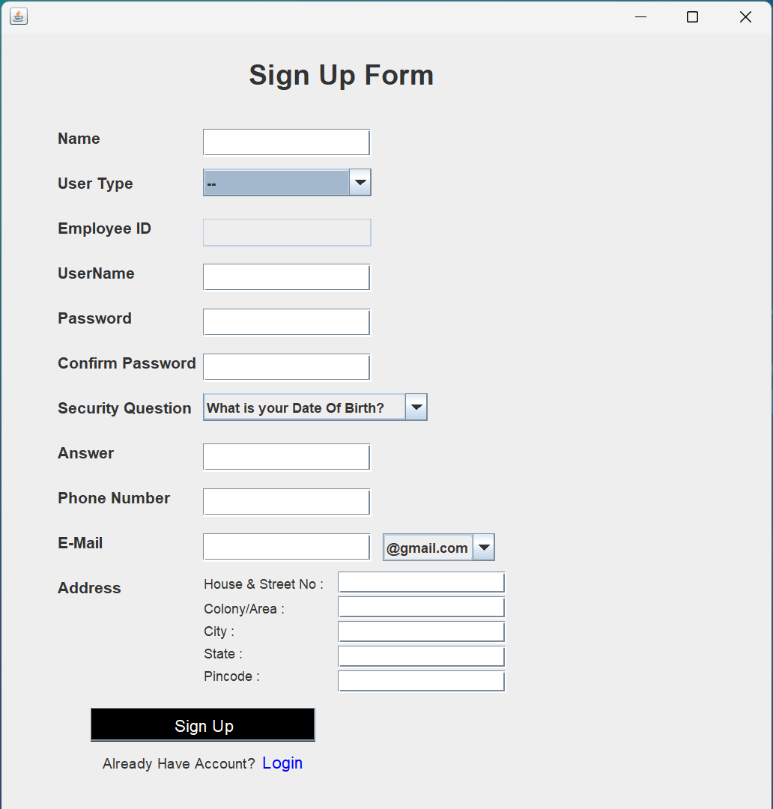

1. **Login**

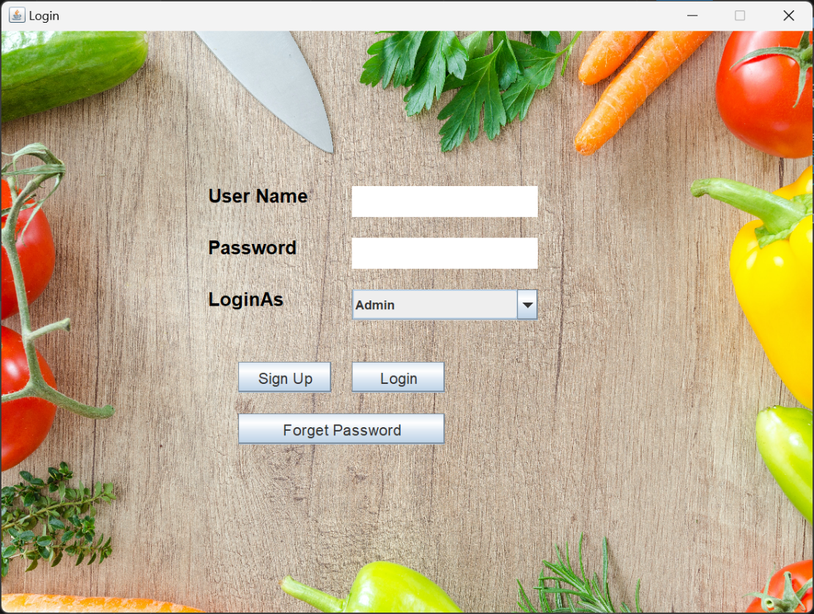

1. **Forget Password**

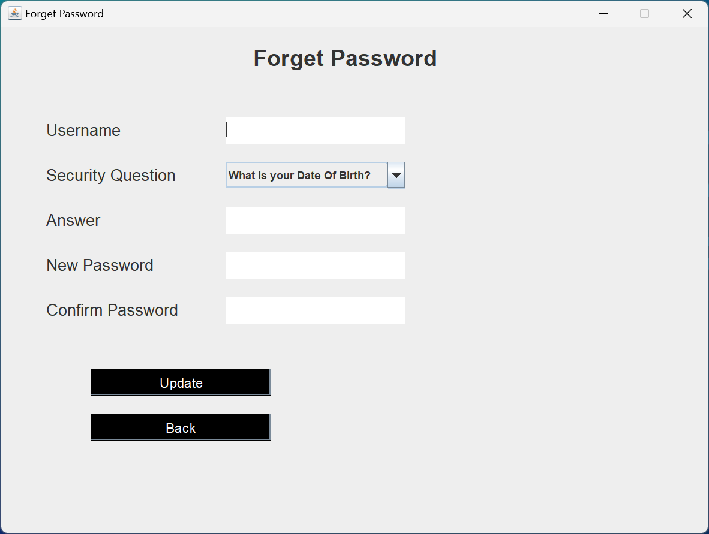

1. **My Profile**

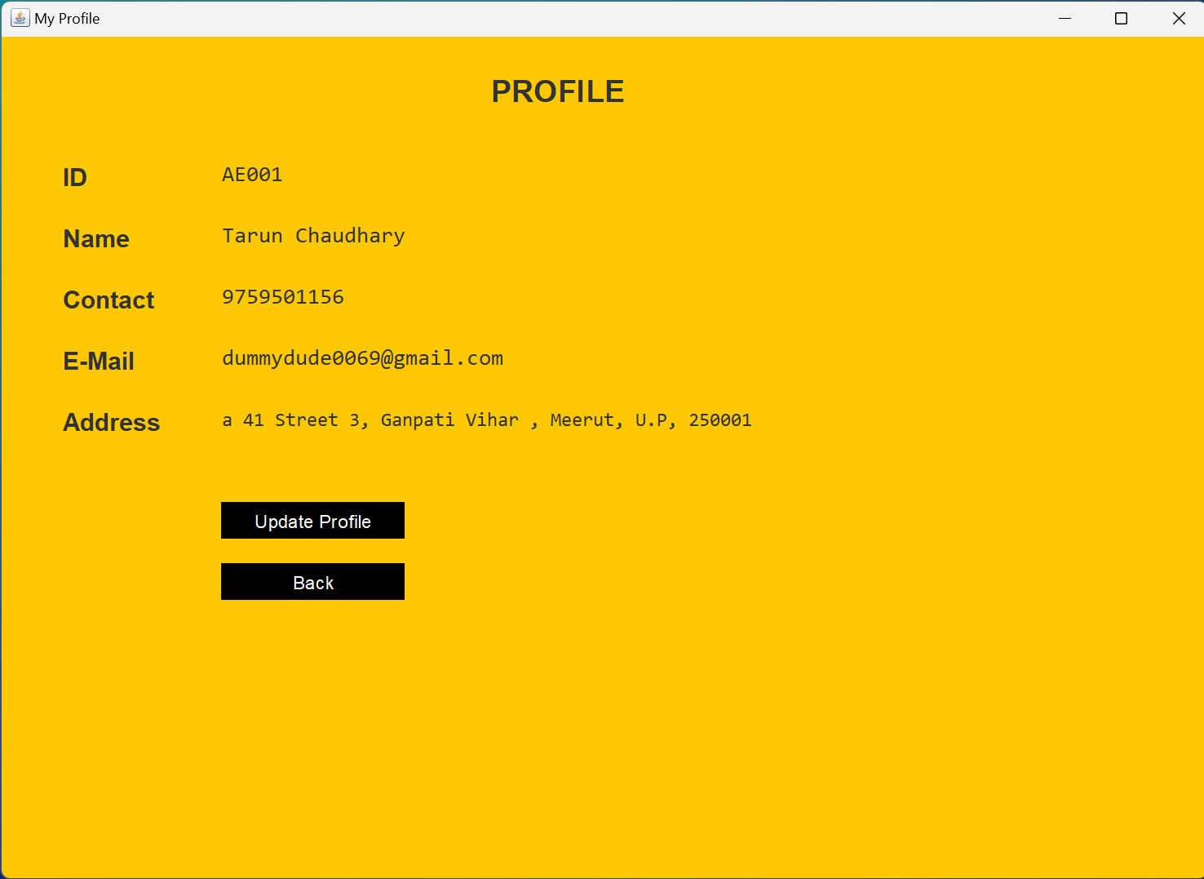

1. **Home Page**

Home – Admin

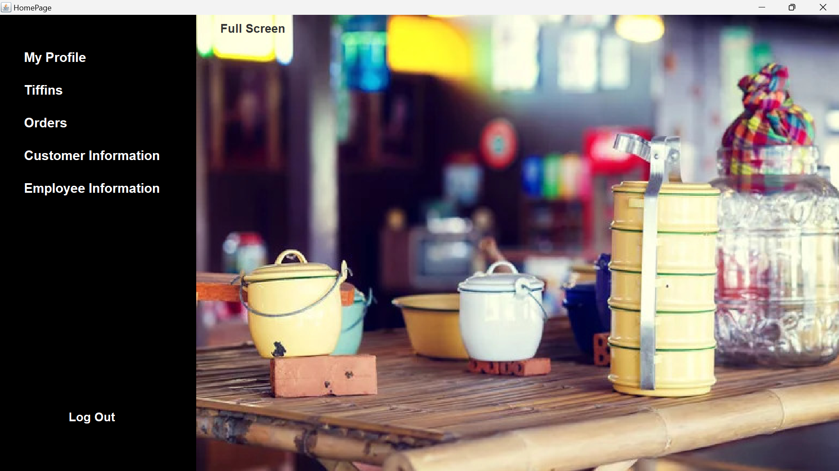

Home – Customer

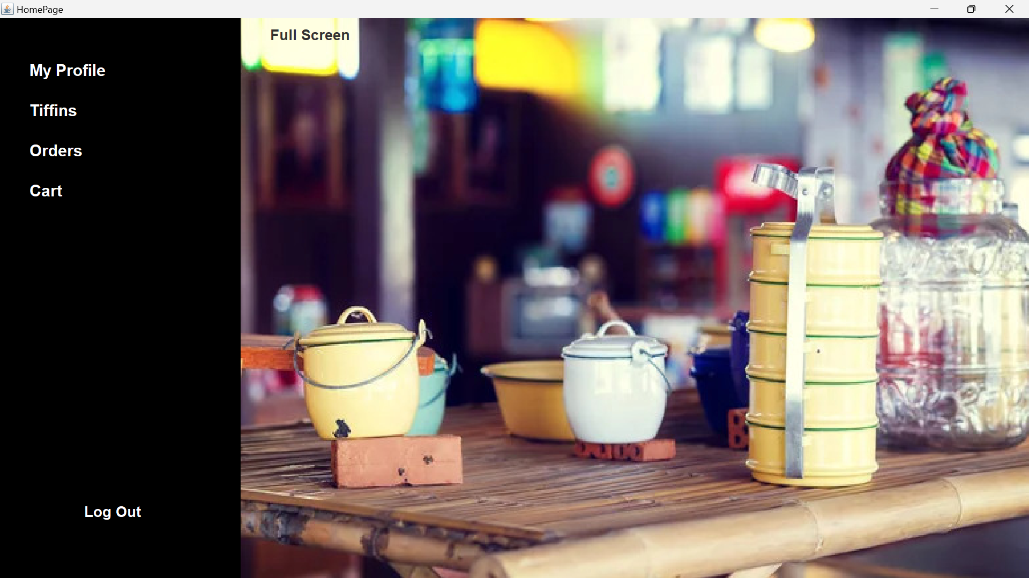

1. **Customer Information**

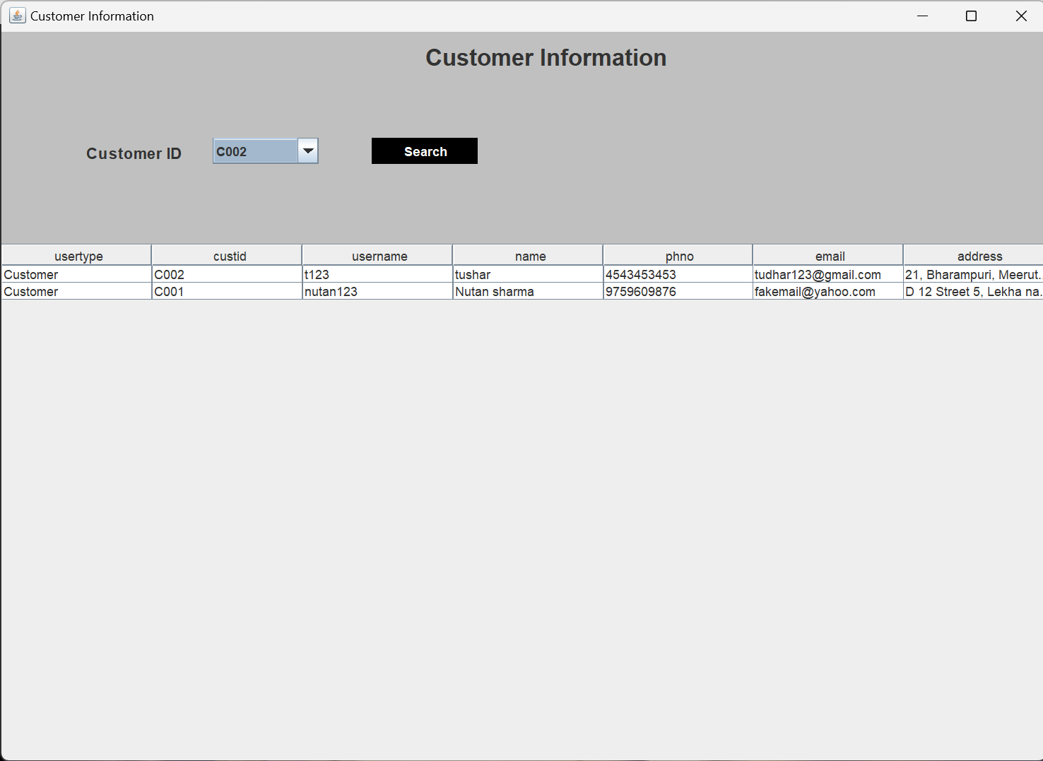

1. **Employee Information**

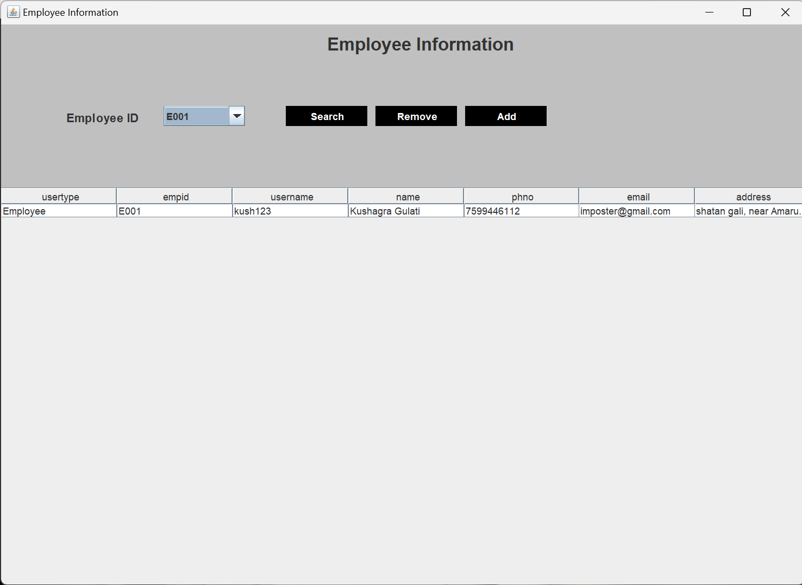

1. **Tiffin Frame**

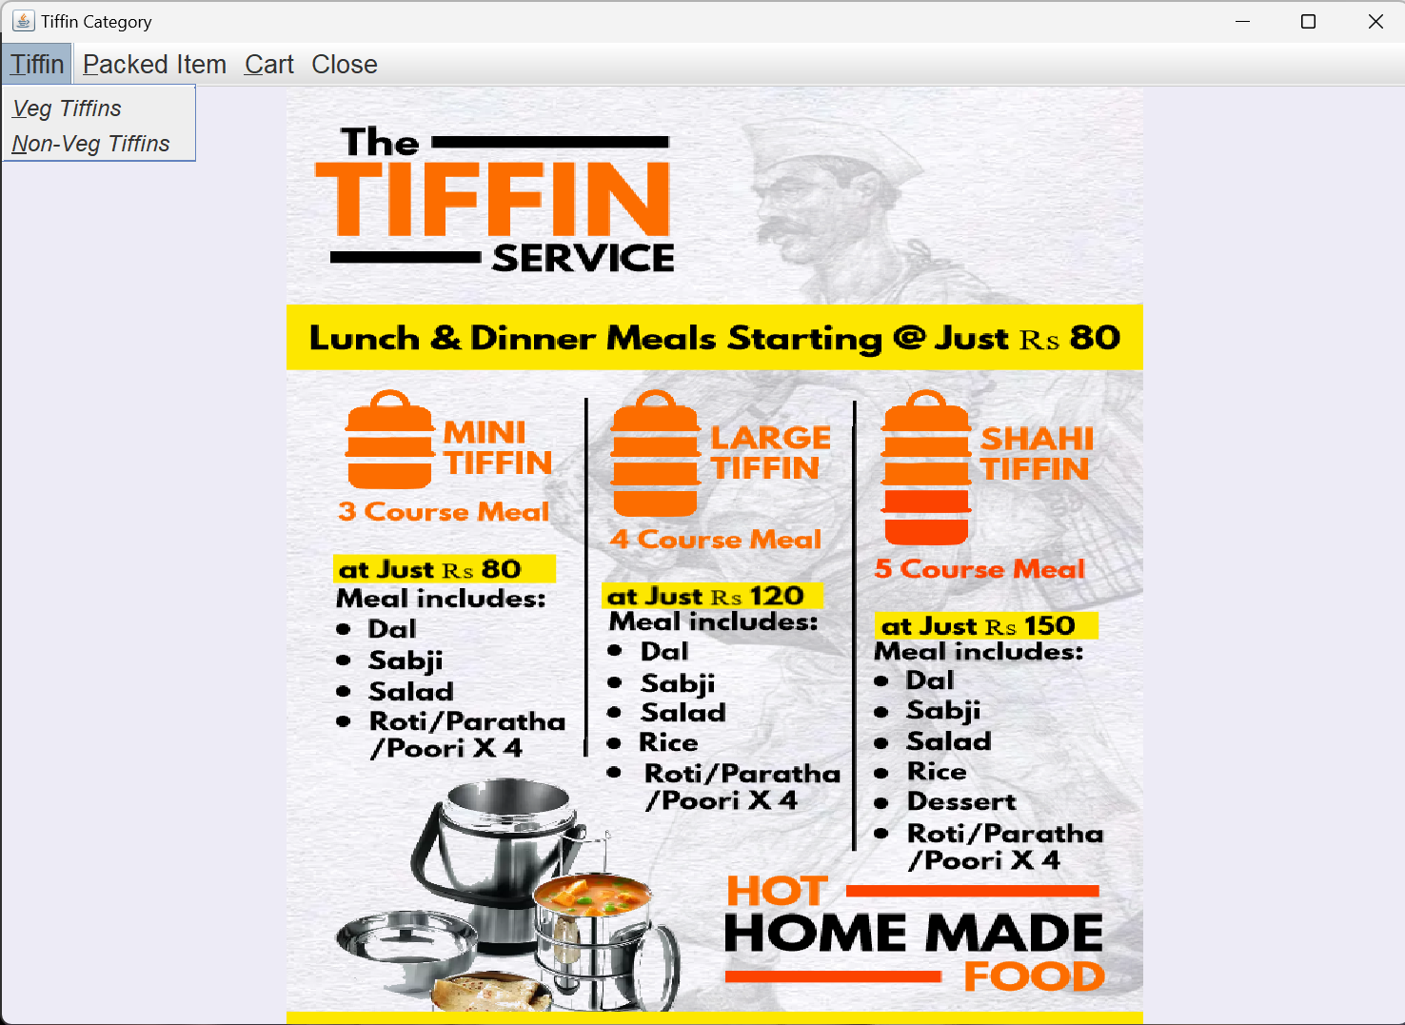

1. **Veg Tiffin**

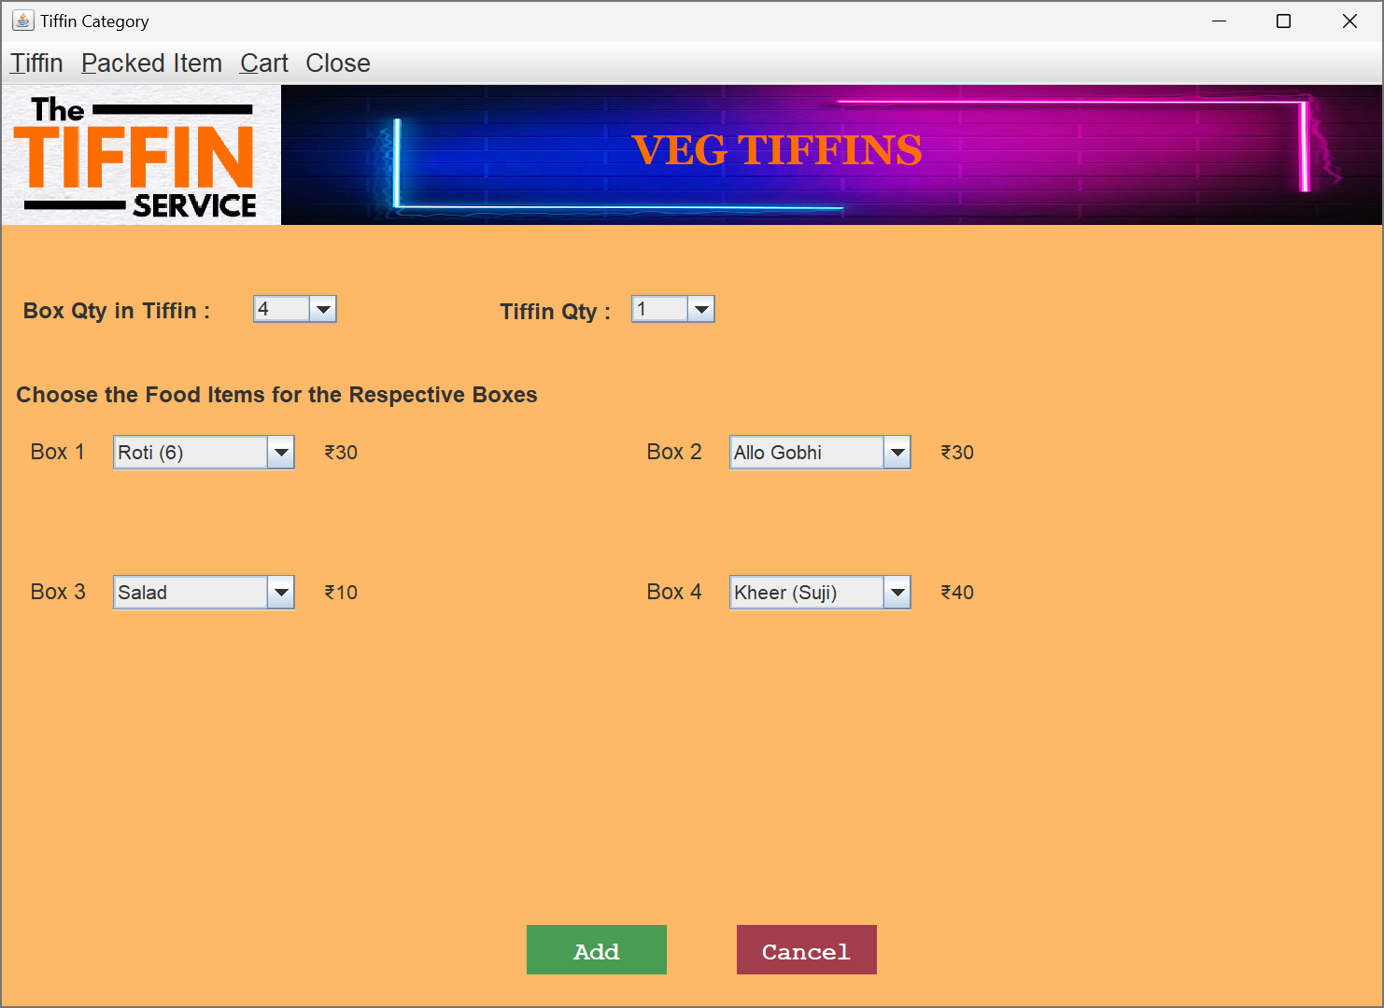

1. **Non-Veg Tiffin**

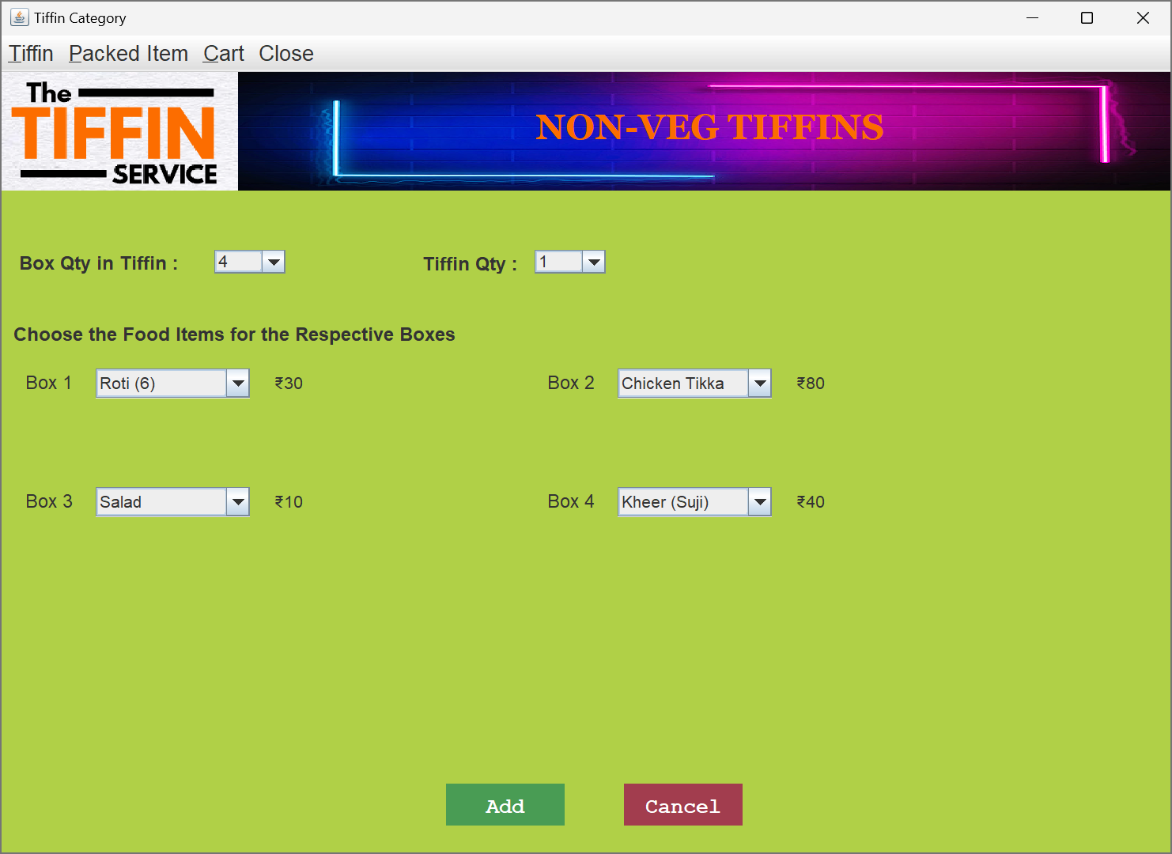

1. **Packed Item**

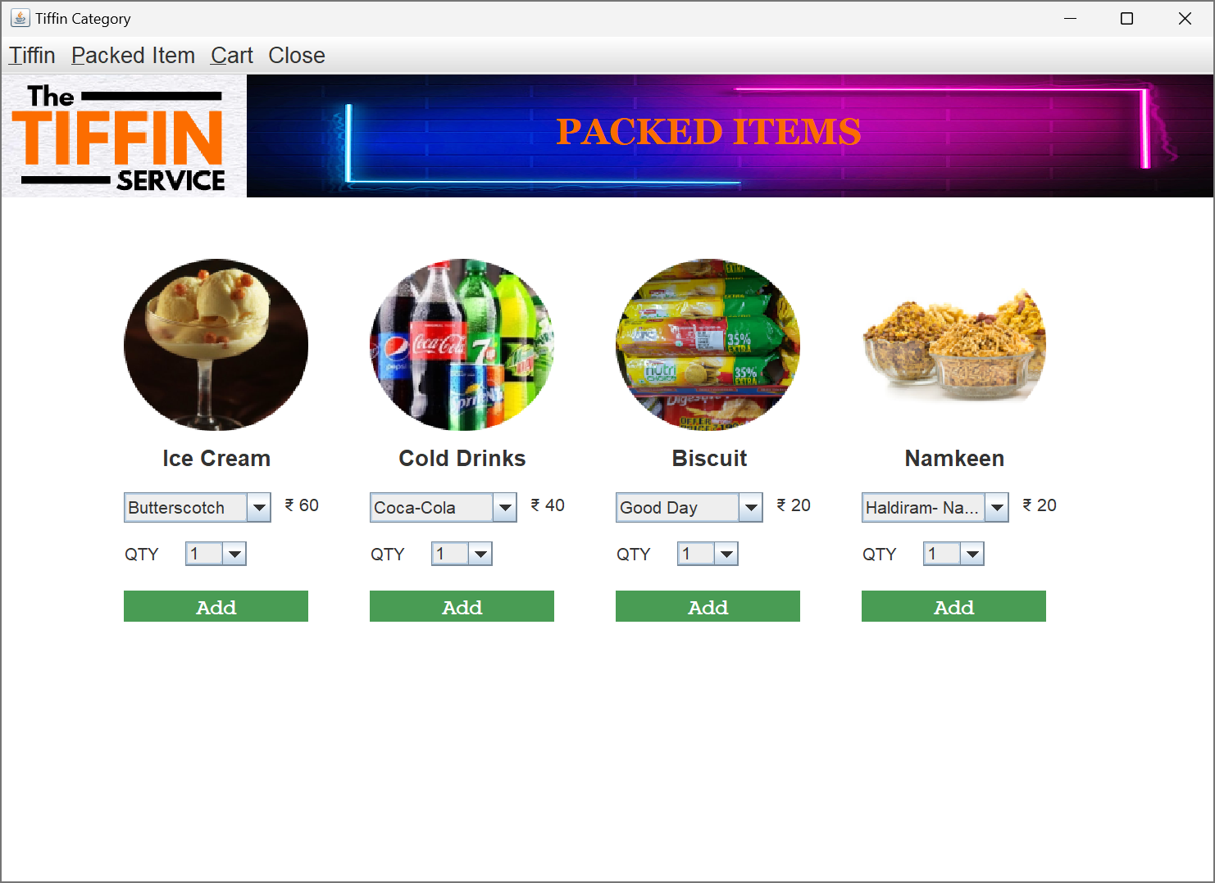

1. **Cart**

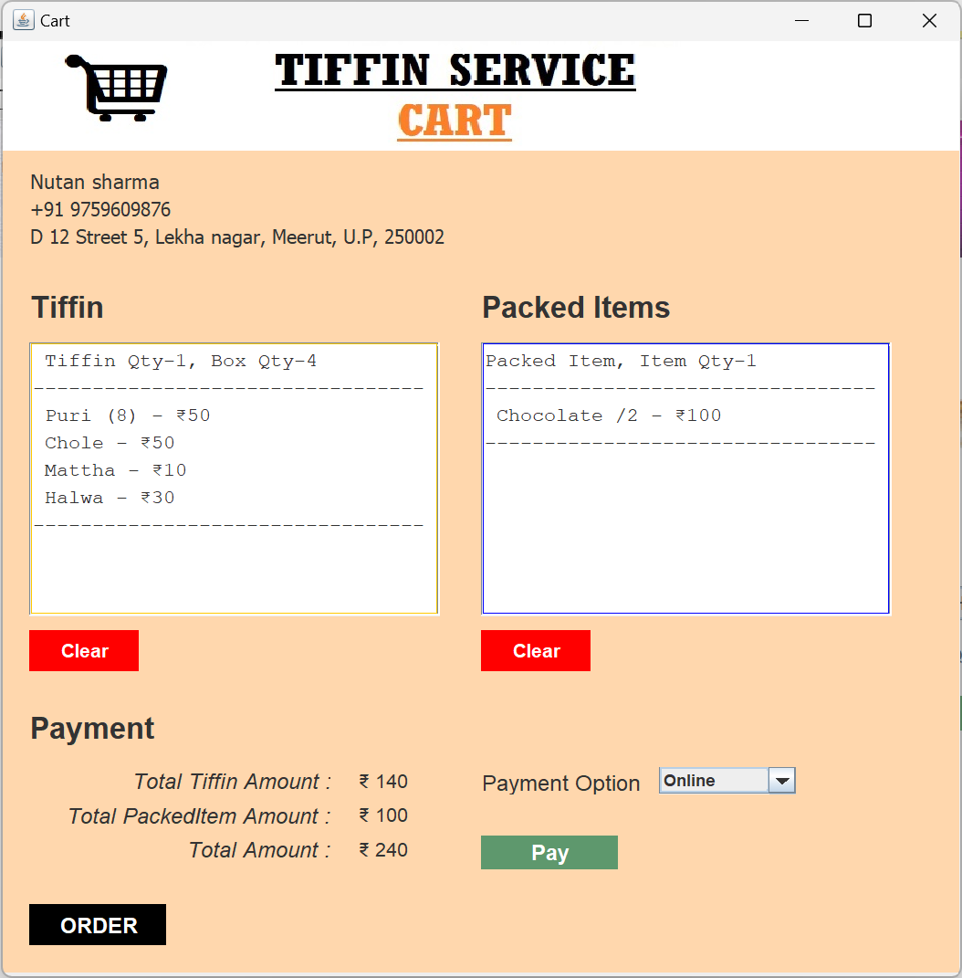

1. **Order**

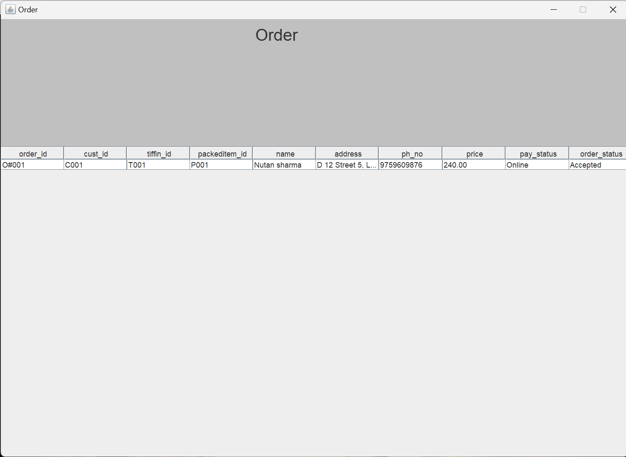

1. **Receipt**

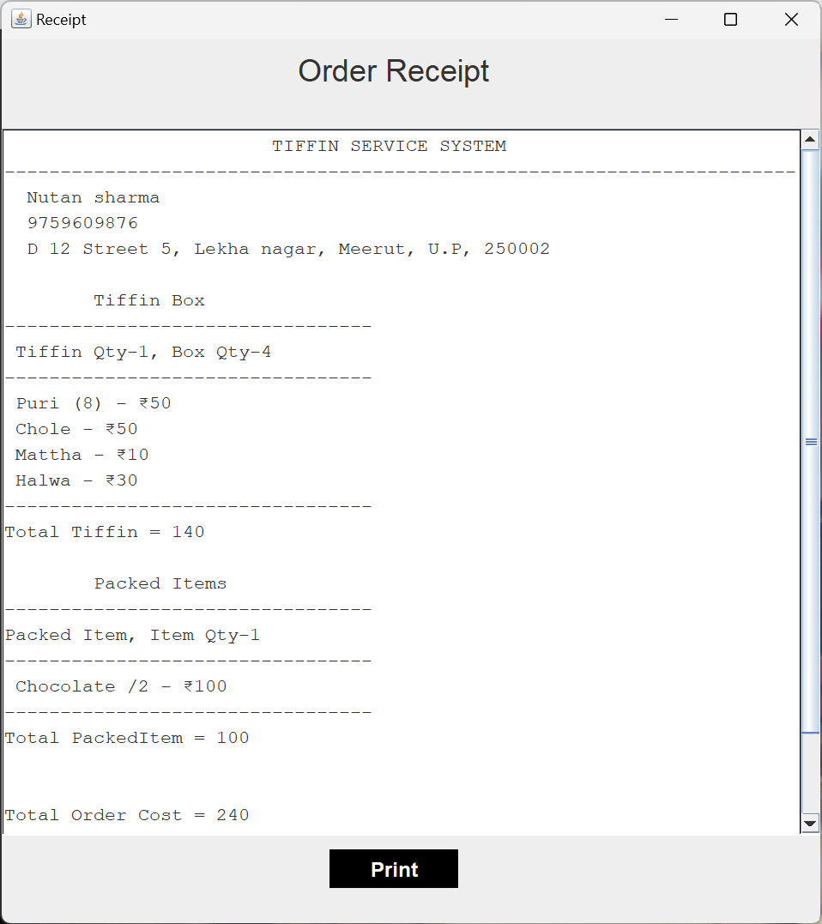

**LIMITATIONS**

1. **Limited Service Area:** Tiffin services are often confined to a specific geographic area due to the need for timely delivery of freshly prepared food. Expanding beyond a certain radius can become challenging and lead to issues with food quality and delivery times.
2. **Delivery Challenges:** External factors like traffic and weather conditions, can impact the timely delivery of tiffin, potentially causing frustration among customers.
3. **Limited Menu Variety:** Offering a wide variety of dishes on a daily basis can be difficult, leading to potential monotony for customers who may be seeking diverse options.
4. **Peak Demand Management:** Managing high demand during peak meal times can strain kitchen operations and lead to delayed deliveries or compromised food quality.
5. **Competition:** The tiffin service industry can be competitive, with multiple players competing for the same customer base. Standing out and attracting customers may require innovative strategies.
6. **Waste Management:** Tiffin services generate packaging waste daily. Implementing eco-friendly packaging and waste management practices can be costly and require ongoing efforts.
7. **Seasonal Fluctuations:** Demand for tiffin services may fluctuate based on seasons, holidays, and events. Managing these fluctuations can be tricky.

**Future Scope of Project**

The future scope of tiffin service systems holds significant potential for growth and innovation. As technology and consumer preferences continue to evolve, tiffin services can explore various avenues to enhance their offerings and address current limitations. Here are some potential future developments for tiffin service systems:

1. **Personalization and Customization:** Advanced data analytics and AI could allow tiffin services to offer personalized meal plans based on individual dietary preferences, allergies, health goals, and cultural tastes.
2. **Subscription Flexibility:** Introducing more flexible subscription models, allowing customers to adjust their meal plans on a week-to-week basis, can accommodate changing schedules and preferences.
3. **Nutrition and Health Focus:** Providing detailed nutritional information and partnering with nutritionists can cater to health-conscious consumers seeking balanced and nutritious meals.
4. **Community Engagement:** Organizing cooking workshops, events, or virtual sessions can help build a sense of community among customers and foster engagement.
5. **Mobile Apps and Online Platforms:** Developing user-friendly apps and online platforms for ordering, customization, and communication can enhance the overall customer experience.

**Bibliography**

1. **W3Schools. "Java Tutorial." W3Schools.com,**

<https://www.w3schools.com/java/default.asp>. W3Schools is a well-known online learning platform that offers tutorials and reference materials for a wide range of programming languages, including Java.

1. **Oracle. "Java SE Documentation." Oracle.com,** <https://docs.oracle.com/en/java/javase/index.html>. This is the official documentation for Java SE (Standard Edition), which is the version of Java that you likely used for your desktop application. This documentation includes guides, tutorials, and API references for Java developers.
2. **JavaWorld. "Java Tutorials." JavaWorld.com,**

<https://www.javaworld.com/category/java-tutorials/>. JavaWorld is a long-running online publication focused on Java development. This website offers a wide range of tutorials, articles, and tips for Java developers, covering topics such as GUI programming, 150150concurrency, and security.

1. **GitHub. "Java Open-Source Projects." GitHub.com,**

<https://github.com/topics/java>. GitHub is a platform for hosting and sharing code repositories. This link takes you to a list of open-source Java projects on GitHub, which can serve as a source of inspiration and learning for your own projects.

1. **Stack Overflow. "Java Questions and Answers." StackOverflow.com,** <https://stackoverflow.com/questions/tagged/java>. Stack Overflow is a popular Q&A community for programmers. This link takes you to a list of Java-related questions and answers on Stack Overflow, which can be a valuable resource for troubleshooting issues and learning from other developers' experiences.